

ANNUAL REPORT No 2

03/2000 – 02/2002

Metrics of Climate Change

CONTRACT No: |  |  |  | EVK2-CT-1999-00021
PROJECT COORDINATOR: |  |  |  | Prof. Dr. Robert Sausen  DLR-Institut für Physik der Atmosphäre  Oberpfaffenhofen, D-82234 Wessling, Germany
CONTRACTORS:
1 | Deutsches Zentrum für Luft- und Raumfahrt e.V. |  |  |  |  | DLR | D
2 | University of Reading |  |  |  |  | UREADMY | UK
3 | Center for International Climate and Environmental Research – Oslo |  |  |  |  | CICERO | NO
4 | Centre National de la Recherche Scientifique |  |  |  |  | CNRS-DR5 | F
5 | Wuppertal Institut für Klima, Umwelt, Energie GmbH |  |  |  |  | WI-CPD | D
PROJECT HOME PAGE: |  |  |  | http://www.pa.op.dlr.de/metric/metric.html
CONTENTS:
Section 1 |  | Management Report
Section 2 |  | Executive Summary
Section 3 |  | Detailed Report
Section 5 |  | Annex

Oberpfaffenhofen, 19 December 2002
Table of Contents

1. Management Report 3
Start of Project 3
Workshops 3
Activities Started / Completed 3
Task 2.1 Emission perturbations (for CTM simulations) 3
Task 2.2 CTM runs 3
Task 2.3 Calculation of RF 3
Task 3.1 Perturbations of climate change agents (for GCM simulations) 3
Task 3.2 (GCM) simulations for idealised forcing perturbations 3
Task 3.3 (GCM) simulations for realistic forcings 4
Task 4.1 Review of available metrics 4
Task 4.2 Calculation of metrics 4
Task 4.3 Scientific evaluation of metrics 4
Task 5.1 Development of refined metrics 4
Task 5.2 Application of refined metric 4
Task 5.3 Scientific evaluation of metric 4
Task 6.1 Political requirements 4
Task 6.2 Evaluation of existing metrics 4
Task 6.3 Evaluation of refined metrics 4
Task 6.4 Overall evaluation 4
Problems 4
Deviation from Work Plan 4
Conclusions 4
2. Executive Summary 5
3. Detailed Report 7
WP 2 Changes in atmospheric composition (CTM simulations) 7
Task 2.1 Emission perturbations (for CTM simulations) 7
Task 2.2 CTM runs 8
Task 2.3 Calculation of RF 11
WP 3 Changes in climate (GCM simulations) 14
Task 3.1 Perturbations of climate change agents 14
Task 3.2 Simulations for idealised forcing perturbations 15
Task 3.3 Simulations for realistic forcings 19
WP 4 Existing metrics 21
Task 4.1 Review of available metrics 21
Task 4.2 Calculation of metrics 23
Task 4.3 Scientific evaluation of metrics 24
WP 5 Refined metrics 26
Task 5.1 Development of refined metrics 26
Task 5.2 Application of refined metrics 27
Task 5.3 Scientific evaluation of metrics 28
WP 6 Political evaluation of metrics 29
Task 6.1 Political requirements 29
Task 6.2 Evaluation of existing metrics 32
Task 6.3 Evaluation of refined metrics 33
Task 6.4 Overall evaluation 33
WP 7 Publications 34
5. Annex 38
Annex 2.1 CTM descriptions 38
LMDzT-INCA 38
OSLO CTM2 38
Annex 2.2 Protocol for model simulations based on IPCC intercomparison. 40

1. Management Report
Period covered: 03/2000 - 02/2002.

Start of Project
The METRIC project started 1 March 2000, i.e., the end of the project is 28 February 2003.

Workshops
15 Feb 2000 | kick-off workshop in Oberpfaffenhofen, assuming the project would start 1 February 2000
15 - 16 Feb 2000 | CTM/GCM modelling workshop in Oberpfaffenhofen
14 - 15 May 2001 | annual workshop 2001 in Oberpfaffenhofen
06 -07 Sep 2001 | WP 6 meeting in Oslo (Norway)
14 - 22 Nov 2001 | working visit of J. Fuglestvedt and T. Berntsen (CICERO) to DLR, funded by DAAD/NFR
14 - 15 Mar 2002 | annual workshop 2002 in Paris
14 - 22 Jun 2002 | working visit of R. Sausen (DLR) to CICERO; funded by DAAD/NFR
07 - 13 Nov 2002 | working visit of J. Fuglestvedt and T. Berntsen (CICERO) to DLR, funded by DAAD/NFR
07 - 08 Nov 2002 | working visit of K. Shine (UREAD) to DLR
19 - 20 Mar 2003 | final annual workshop in Brussels (scheduled)

Activities Started / Completed

Task 2.1 Emission perturbations (for CTM simulations)
A base case and 4 perturbation scenarios were defined. Milestones M2.1 and M2.2 were achieved; the first and second phases of Task 2.1 are completed.

Task 2.2 CTM runs
CICERO and CNRS-DR5, both made several improvements to their CTMs, which will enable a better coupling to the CTM simulations to performed in year 2 and allow a better computational performance. A several sets of simulations were performed. M2.3 and M2.4 were achieved.

Task 2.3 Calculation of RF
Radiative forcing was calculated for a large number of cases. M2.6 was acchieved.

Task 3.1 Perturbations of climate change agents (for GCM simulations)
A set of cases of idealised forcing perturbations (CO₂, solar, ozone) were defined. M3.1 and M3.3 were achieved in year 1. f M3.2 will be achieved early in year 3. M3.4 (ozone perturbations by aircraft) was delayed, awaiting the simulations by the CTMs in Task 2.2 and will also be achieved early in year 3.

Task 3.2 (GCM) simulations for idealised forcing perturbations
DLR, UREAD and CNRS-DR5 have performed GCM simulations for the perturbations defined in Task 3.1. M3.5 was achieved in year 1. Some additional ideas for causes of enhanced climate sensitivity have been analysed and published. It has been decided that more analysis of the causes of GCM differences from the runs in the first year of this task should replace significant additional GCM simulations as envisaged for the second phase. M3.6 was achieved.

Task 3.3 (GCM) simulations for realistic forcings
DLR, UREAD and CNRS-DR5 have performed GCM simulations using a selection of the ozone perturbations derived from the CTM simulated ozone change patterns (Task 2.2). An initial analysis of these simulations has been performed and more detailed analysis will continue in year 3; hence, Task M3.3. is on schedule.

Task 4.1 Review of available metrics
A review paper was completed during the reporting period. The paper is more comprehensive than originally intended and also cover some aspects of Tasks 4.2 and 6.1. M4.1 was achieved. A revision is scheduled for year 3.

Task 4.2 Calculation of metrics
A software tool for convenient calculation of GWP has been developed. Some metrics (e.g., radiative forcing, climate sensitivity parameter) have been calculated for cases from Task 3.2. M4.2 is delayed.

Task 4.3 Scientific evaluation of metrics
This task is on schedule.

Task 5.1 Development of refined metrics
This task has started, first sets of refined metrics are available. M5.1 is achieved.

Task 5.2 Application of refined metric
This task has been postponed totally to year 3.

Task 5.3 Scientific evaluation of metric
This task has been postponed totally to year 3..

Task 6.1 Political requirements
This task has started. M6.1 is not yet achieved, but a draft report is available.

Task 6.2 Evaluation of existing metrics
This task has started. M6.2 is not yet achieved, but a draft report is available.

Task 6.3 Evaluation of refined metrics
This task has not yet started.

Task 6.4 Overall evaluation
This task has not yet started.

Problems
It appears difficult to close the "language" gap between natural science and political sciences, though some progress has been made in year 3.

Deviation from Work Plan
The simulations for the aircraft related cases are delayed due to difficulties outside of METRIC. More time was spent to the idealised GCM simulations than originally planned due to the highly interesting results obtain. This required additional simulations in order to better understand the results. The work on refined metrics will have its core in year 3.

Conclusions
The METRIC project has made good progress, despite the above mentioned problems. The objectives of METRIC remain valid. The results of METRIC will change our conception of the possibility of describing climate change by simple metrics like GPW.

Executive Summary
Using two different CTMs (OSLO CTM2 run by CICERO and LMDz-INCA run by CNRS) the response of the chemical composition of the atmosphere to 4 different scenarios of localised emissions of CO and NOx was simulated. The emissions scenarios were:
- CO fossil fuel surface emissions increased over Western Europe,
- CO Fossil fuel surface emissions increased by over South East Asia,
- NO_{x} Fossil fuel surface emissions increased by over Western Europe,
- NO_{x} Fossil fuel surface emissions increased by over Southeast Asia.
Both models show that the NOx emissions in Southeast Asia much more efficiently increase the ozone burden than NOx emissions in Europe do. A qualitative similar response is found for the CO perturbations, however, the agreement between the two CTM is less impressive. The corresponding radiative forcings were calculated with three different models. The model-to-model variability is smaller than the differences from scenario to scenario. The largest radiative forcing is found for the NOx perturbation in South East Asia, the smallest for the NOx perturbation in Europe. The radaitive forcings from the two CO perturbations are more similar, with only slightly larger values for the Southeast Asian case.

The impact of geographically inhomogeneous perturbations of radiative active species was studied with two comprehensive GCMs (ECHAM4 run by DLR and LMDz run by CNRS) and one intermediate GCM (run by UREAD). The following perturbations, each scaled to have the same global mean radiative forcing of 1 Wm⁻², were considered:
- a globally homogeneous CO₂ increase,
- a CO₂ increase confined to the tropics,
- a CO₂ increase confined to the extra-tropics,
- a CO₂ increase confined to the northern extra-tropics,
- a globally homogeneous increase of the solar irradiance,
- an increace of the solar irradiance confined to the tropics,
- an increace of the solar irradiance confined to the extra-tropics,
- a globally homogeneous ozone increase in the upper troposphere,
- an upper troposphere ozone increase confined to the tropics,
- an upper troposphere ozone increase confined to the extra-tropics,
- an upper troposphere ozone increase confined to the northern extra-tropics,
- a globally homogeneous ozone increase in the lower stratosphere.
Despite the fact that the models have different climate sensitivity parameters for a homogeneous CO₂ perturbation, the normalised response in the global mean temperature, i.e., the temperature change normalised by the respective response for the homogeneous CO₂ forcing, is similar for all models. The tropical and extra-tropical perturbations result in smaller or larger temperature changes, respectively. The response to ozone perturbations in the upper troposphere tends to be smaller than for CO₂, while the response to the ozone increase in the lower stratosphere is the largest for each model.
The climate sensitivity parameters have also been calculated for some of the ozone perturbations calculated with the CTMs, but drawing conclusions would be premature.

Available metrics of climate change, in particular radiative forcing and global warming potential have been reviewed. There usefulness for "measuring" climate change was discussed and some limitations were shown. E.g. it was demonstrated that reductions in CO₂ emissions and equivalent CH₄ emissions (in terms of GWP) can result in quite different temperature responses.

First suggestions for refined metrics have been made, but they need to be tested.

Criteria for applicability of metrics for policy makers have been identified, e.g., regarding the procedural requirements at least three categories have to be considered:
(1) Simplicity and transparency: The metric should be easy to understand and to be used.
(2) Flexibility: The methodology should be open to advancements in scientific knowledge and to changes in the negotiation process.
(3) Political feasibility: Uncertainties should be reduced to the maximum extent possible.

So far, 12 papers were published in or have been submitted to peer reviewed journals. 9 further publications and 31 oral presentations with topics related to METRIC were made. The METRIC web site was updated.

Detailed Report

WP 2 Changes in atmospheric composition (CTM simulations)

Task 2.1 Emission perturbations (for CTM simulations)

Objectives

The main objective of Task 2.1 is to define a set of emission perturbations to be used in the chemistry transport models.

Methodology and scientific achievements related to Task including contribution from partners

Base case

The base case simulation for both models (UIO2 and LMDzT-INCA, see Annex 2.1) is defined based on the IPCC (2001) OXCOMP inter-comparison exercise. The protocol for model simulation is provided in Annex 2.2.

Perturbation scenarios

An initial set of 6 emission scenarios has been prepared for the METRIC chemical model simulations. The simulations have been conducted for 18 and 24 months for UIO2 and LMDzT-INCA, respectively, and the last 12 months are used for intercomparison and as input for GCM perturbation studies. In order to test the sensitivity to emission pulse location, 2 regions have been retained with approximately the same area.

Region 1: Mid-latitude location corresponding to Western Europe and defined with the boundaries [40N-60N], [10W-20E].
Region 2: Tropical region corresponding to South-East Asia and defined with the boundaries [10N-30N], [100E-120E].

The 6 initial scenarios are:
- CO Fossil fuel surface emissions increased by 40 Tg over Region 1 on an annual basis. The emissions are uniformly increased within the region in order to provide a total 40 Tg.
- CO Fossil fuel surface emissions increased by 40 Tg over Region 2 on an annual basis.
- NO_{x} Fossil fuel surface emissions increased by 1 TgN over Region 1 on an annual basis.
- NO_{x} Fossil fuel surface emissions increased by 1 TgN over Region 2 on an annual basis.
- NO_{x} Aircraft Emissions increased over Region 1 on an annual basis.
- NO_{x} Aircraft Emissions increased over Region 2 on an annual basis.

A second set of perturbations has been defined during the annual workshop in Paris in March 2002. The corresponding CTM simulations will be performed during the last reporting period. The additional simulations will help to test the non-linearity in the system and the sensitivity to background NOx concentrations. These simulations will be performed by either UiO2 or LMDzT-INCA.
- NO_{x} emissions for 2050 (without aircraft) will be performed by the CICERO using UiO2.
- Aircraft emissions will be added to the background emissions of perturbation No. 7 (CICERO).
- Combined CO and NO_{x} perturbations for Region 1 (for present day conditions) performed by IPSL (LMDz).
- Repeat perturbation No. 3, but with doubled background NO_{x} simulations (IPSL).

This results in a total of 4 additional simulation runs for the CTM groups.

Socio-economic relevance and policy implication

No direct socio-economic or policy implications are related to this work package.

Discussion and conclusion

An initial set of 6 scenarios has been defined in order to simulate the response of the chemistry (tropospheric ozone and OH burden) to emission perturbations of CO and NOx and to investigate the sensitivity to perturbations applied at mid-latitudes and in the tropics. An additional set of 4 simulations will also been set up to further investigate the role of non-linearities and background NOx concentrations. These scenarios have been provided to the CTM simulation WP (Task 2.2). At this stage, due to a delay in the delivery of 2000 aircraft emissions only perturbations 1 to 4 of the initial simulation sets have been simulated with the CTMs.

Plan and objectives for next period

The aircraft emissions for 2000 conditions and the modified emissions (scenarios 5 to 10) will be prepared and provided to the CTMs. The emission perturbation files will be prepared for the second set of simulations. In particular, the 2050 background emissions will be prepared on the basis of the IPCC SRES scenarios.

Task 2.2 CTM runs

Objectives

The objectives of Task 2.2 are
- to determine the change in tropospheric ozone and OH concentrations (and methane life-time) associated with selected perturbations of surface and free atmosphere emissions (e.g., from aircraft) of source gases (i.e., NOx, CO, NMHCs);
- to assess the dependence of changes in the O₃ and OH concentrations on the location of the perturbation in the emissions (e.g., mid-latitudes versus tropics, surface versus upper troposphere);
- to calculate the future levels of ozone associated with additional emissions in ozone precursors including aircraft emissions, on the background of scenarios of future emissions (based on IS92 and the IPCC/SRES 2000).

Table 2.1: Globally and annually averaged ozone and OH changes as calculated by the 2 models
LMDzT-INCA (blue, first row each) and UIO2 (red, second row each).
 | Base case | Scenario1  CO Europe | Scenario 2  CO Asia | Scenario 3  NO_{x} Europe | Scenario 4  NO_{x} Asia
Methane Lifetime (yr) | 11,534 | 0,072 | 0,069 | -0,014 | -0,054
 | 7,740 | 0,026 | 0,025 | -0,007 | -0,025
OH density (10⁵ molec./cm³) | 7,624 | -0,053 | -0,058 | 0,010 | 0,043
 | 11,536 | -0,036 | -0,046 | 0,008 | 0,032
O₃ burden (Tg) | 388,399 | 0,796 | 0,885 | 0,179 | 1,232
 | 420,000 | 0,759 | 1,150 | 0,287 | 1,140

Methodology and scientific achievements related to Task including contribution from partners

The 2 CTMs used for this task are LMDzT-INCA of CNRS and UIO2 of CICERO. A description of the models is provided in Annex 2.1. Table 2.1 provides a summary of the various perturbations and gives the globally and annually averaged ozone and OH change for the 2 models and for scenarios 1-4. The results for LMDzT-INCA are given in blue (first line) and for UIO2 in red (second line). Even if the model results differ in terms of magnitude of the response, several basic features emerge from the results:

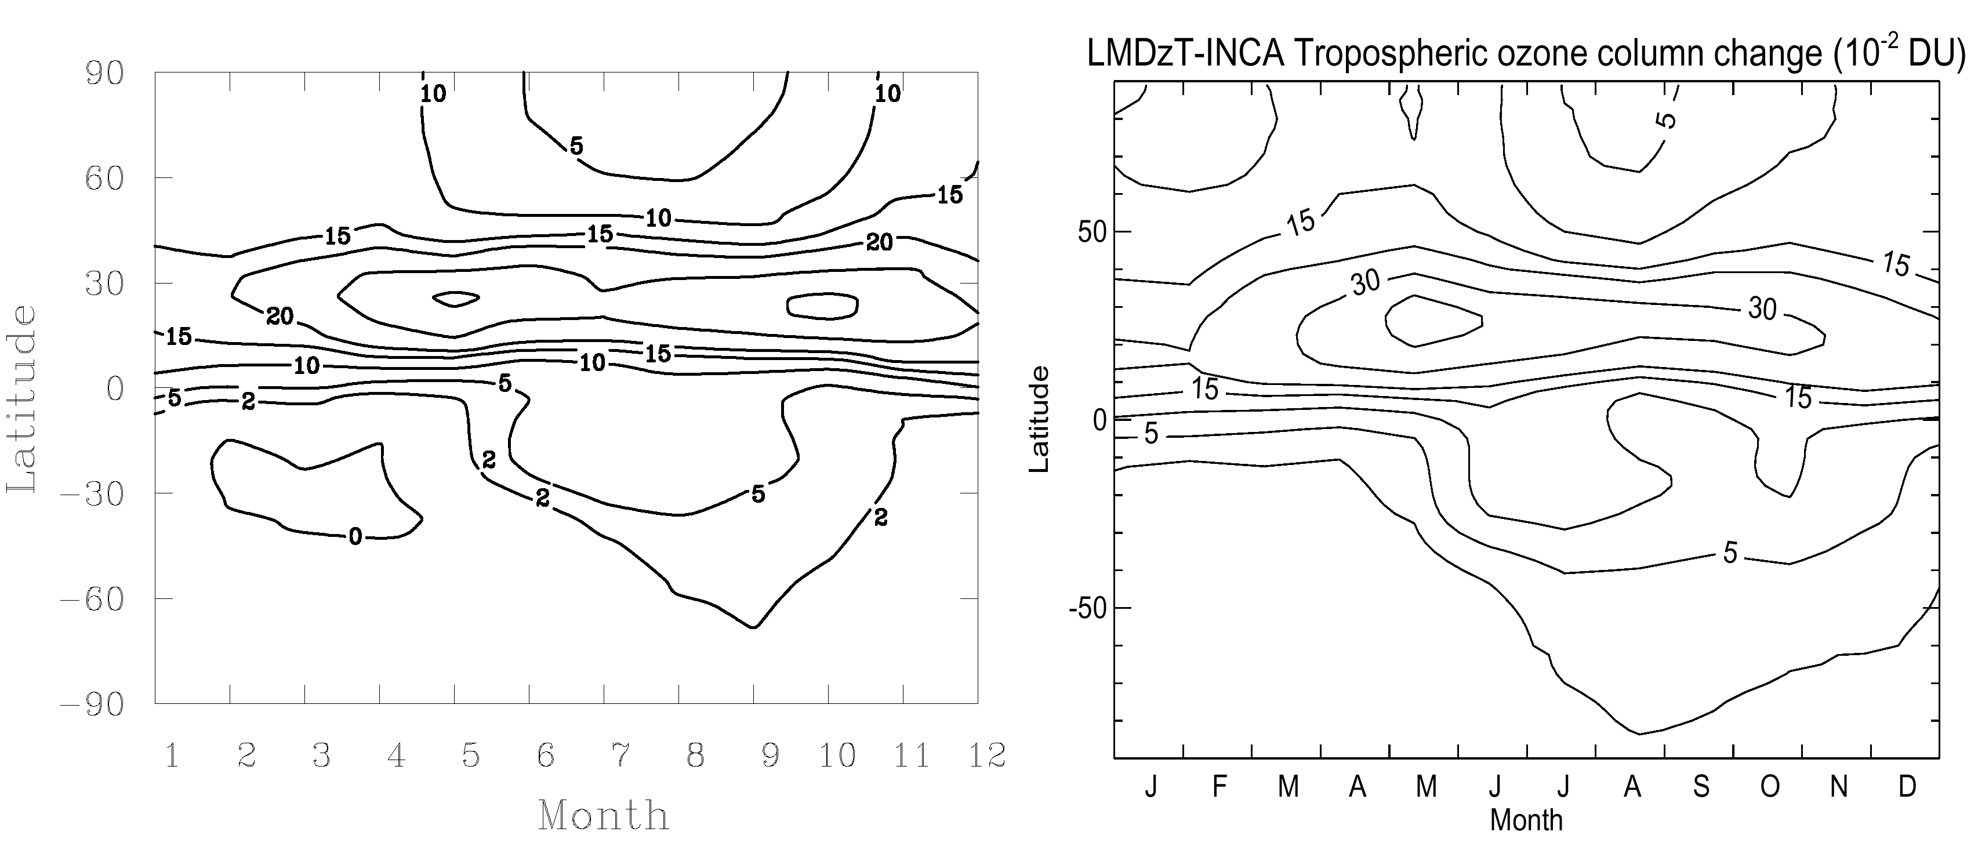
Figure 2.1: Change in total ozone (DU) calculated for scenario 4 (NOx perturbation applied over Asia) as simulated by UIO2 (left) and LMDTz-INCA (right).

An important feature is the higher efficiency in producing ozone in the case of a perturbation in the tropics. This finding is associated with a more efficient chemistry in the tropics and different mixing regimes between the 2 regions. Due to a shorter lifetime, the NO_{x} distribution is more affected by dynamics than in the case of CO. The annual and geographical distribution of the perturbation is similar in both models. In the case of perturbation at mid-latitudes of the northern hemisphere a strong seasonal cycle is calculated peaking in summer when photo-chemistry is more intense (not shown). In contrast (Fig. 2.1), the seasonal cycle is weaker if the perturbation is located in the tropics.

An important difference between the two types of perturbations (Europe versus South East Asia) is the difference in dynamic regimes. In the tropics, rapid upward transport prevails and the precursors are vigorously redistributed in the vertical. Figure 2.2 illustrates this feature and shows the change in ozone (ppbv) calculated for scenario 4 (change in NOx in SE Asiaas simulated by LMDzT-INCA). In this case, the ozone perturbation peaks clearly in the upper troposphere during July and reaches about 1 ppbv. Since the radiative forcing of ozone is the most sensitive to perturbations occurring in this region, we anticipate a higher radiative forcing when the change in emissions is applied in the tropics.

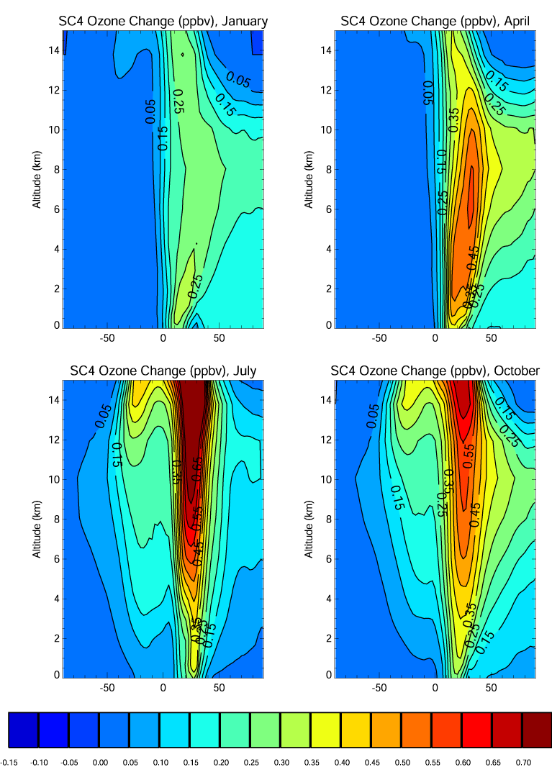

Figure 2.2: Change in zonal mean ozone mixing ratio (ppbv) for scenario 4 (NOx perturbation in South-East Asia) and for January, April, July, and October conditions as simulated by LMDzT-INCA.

Socio-economic relevance and policy implication

No direct socio-economic or policy implications are related to this work package.

Discussion and conclusion

The CTM simulations show that ozone is most sensitive to perturbations in NOx applied in the tropics. Even if the two model results differ in terms of the magnitude of the ozone change, the seasonal and geographical distributions are quite similar. A strong seasonal cycle is predicted for a mid-latitude perturbation peaking in summer. In the tropics, a maximum ozone perturbation is calculated in the upper troposphere where the impact on the radiative forcing is the largest.

Plan and objectives for next period

Over the next period, scenarios 5 and 10 will be performed and results analysed.

Task 2.3 Calculation of RF

Objectives

The objectives of this task are
- to quantify the indirect RF associated with changes in ozone and CH₄ concentrations;
- to calculate RF for various other perturbations.

Figure 2.3: Ozone radiative forcings calculated by the 3 RTMs and for scenarios 1 to 4.

Methodology and scientific achievements related to Task including contribution from partners

The radiative forcing due to the changes in tropospheric ozone described above has been calculated with the radiative transfer models (RTM) of the University of Reading (Forster et al. 2000), DLR, and IPSL. DLR uses the ECHAM4 model to calculate radiative forcing in a GCM as described by Stuber et al. (2001) and IPSL uses the radiation code from LMDzT.

Table 2.2 Global ozone change (Tg) and annual mean net radiative forcing (mW/m²) due to enhanced ozone concentrations for the 4 perturbation experiments.

 |  | CO-Europe |  | CO-Asia |  | NOx-Europe |  | NOx-Asia
 |  | UiO2 | LMDzT | UiO2 | LMDzT | UiO2 | LMDzT | UiO2 | LMDzT
ΔO₃ (Tg) |  | 0.759 | 0.796 | 1.15 | 0.885 | 0.287 | 0.179 | 1.14 | 1.23
RF (mW/m²) | DLR | 2.8 | 3.7 | 4.4 | 4.4 | 1.1 | 0.9 | 5.0 | 6.1
RF (mW/m²) | IPSL | 2.5 | 3.1 | 3.8 | 3.6 | 0.9 | 0.8 | 4.0 | 5.8
RF (mW/m²) | Reading | 3.1 | 3.5 | 4.9 | 4.1 | 0.87 | 0.74 | 4.8 | 5.8

The global annual mean net RF (net is the sum of the longwave and shortwave RF) given in Table 2.2 and Figure 2.3 show several interesting features. The ozone RF caused by CO emissions in Europe is smaller than for CO emissions in SE-Asia by 15–35% depending on the combination of CTM and RTM model used. In the case of ozone perturbations from NOx emissions the differences between the regions (the NOx-Asia versus NOx-Europe cases) are much larger. The RF for the NOx-Asia case exceeds those for the NOx-Europe case with factors between 4.5 (UiO2, DLR) and 7.8 (LMDzT, Reading). The latter range is in good agreement with previous work (Fuglestvedt et al. 1999, Derwent et al. 2001)
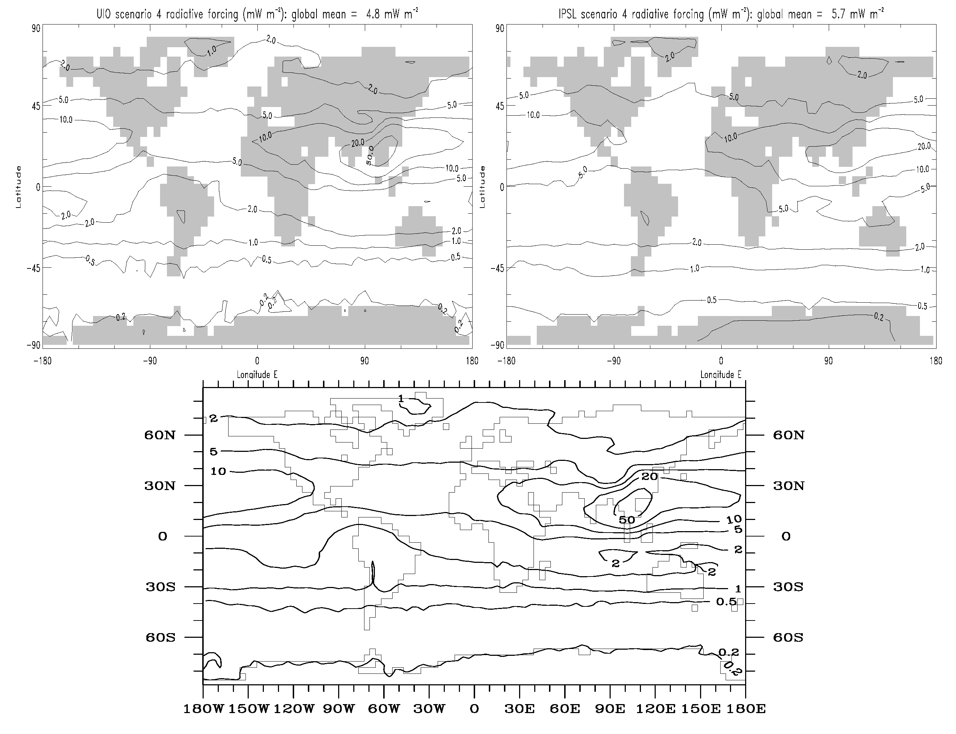

Figure 2.4; Annual net radiative forcing (mW/m²) due to changes in tropospheric ozone for the NO_{x}-Asia case. Upper panels show the results from the Reading model (left UiO2, right LMDzT-INCA), lower panel from the DLR model (UiO2 only).

The geographical distribution of the annual net RF in the NOx-Asia case is shown in Figure 2.4. All three estimates show a significant spatial inhomogenity in the RF distribution, with a maximum over the source region in SE Asia. In the case of the UiO2 results (and both RTMs) the local annual mean RF exceeds 0.05 W/m². The upper two panels show how the differences generated by the CTMs influence the RF in the Reading RTM. Although the overall distribution is quite similar, there is a tendency to a more widespread impact in the RF calculated based on the LMDzT-INCA results than in the corresponding UiO2 results. This is caused a more efficient transport of tracers (ozone and ozone precursors) in LMDz-INCAT than the UiO2 model. This again could be a manifestation of differences in meteorology (winds and convection), which drives the transport in the two models, but is probably more related to a larger numerical diffusion in the advection scheme of LMDzT-INCA. The differences caused by using two different RTM on the same ozone perturbation (upper left panel, UiO2/Reading versus the lower panel, UiO2/DLR) is generally small.

Table 2.3: Estimated changes in methane lifetime, methane concentrations (at steady state), and radiative forcing caused by the methane perturbations.

Perturbation | UiO2 |  |  | LMDzT-INCA
Perturbation | Δτ_{CH4} (yr) | ΔCH₄ (ppbv) | RF (mW/m²) | Δτ_{CH4} (yr) | ΔCH₄ (ppbv) | RF (mW/m²)
CO-Europe | + 0.026 | 9.0 | 3.4 | + 0.072 | 16.8 | 6.3
CO-Asia | + 0.025 | 8.8 | 3.3 | + 0.069 | 16.1 | 6.0
NOx-Europe | - 0.0068 | -2.4 | -0.89 | - 0.014 | -3.3 | -1.2
NOx-Asia | - 0.025 | -8.6 | -3.2 | - 0.054 | -12.6 | -4.7

Based on the initial changes in methane lifetime (Table 2.3), the changes in methane concentrations at steady state can be estimated even if the CTM simulations are not run for the long period of time (several decades) required to get to steady state for methane (cf. Fuglestvedt et al. 1999). The estimated changes in methane require the use of a feedback factor, which is model dependent. To derive the numbers for ΔCH₄ in Table 2.3 we have used the feedback factor of 1.54 as in Fuglestvedt et al. (1999) for both UiO2 and LMDzT-INCA. The corresponding RF can then be estimated based on the simple equations given in IPCC (1997).

The radiative forcing due to ozone and methane changes are both positive and similar in magnitude in the case of additional CO emissions, while for NOx emissions the radiative forcing from ozone and methane is of opposite sign. This is because NOx emissions also enhance OH, leading to a reduction of the lifetime of methane. In the NOx-Europe case, the magnitude of the radiative forcing from ozone and methane are quite similar (although with different signs), while in the NOx-Asia case the magnitude of the RF due to ozone is 50% larger than for methane.

Socio-economic relevance and policy implication

The results may allow the conclusion that reducing NO_{x} emisssions is Asia will be more efficient with respect to limit anthropogenic climate change than the same reduction in Europe.

Discussion and conclusion

See paragraph above.

Plan and objectives for next period

The radiative forcing calculations for scenarios 5 and 6 of the initial set and for the new set of simulations (7 to 10) will be performed when the CTM results become available.

WP 3 Changes in climate (GCM simulations)

Task 3.1 Perturbations of climate change agents

Objectives

The objective of this task is
- to define sets of perturbations of climate change agents for GCM simulations.

Methodology and scientific achievements related to Task including contribution from partners

This task requires the definition of General Circulation Model (GCM) experiments that are performed by the three METRIC groups running GCMs (i.e. DLR, LMD and UREAD). All model calculations use mixed-layer oceans run to equilibrium with the forcing.

The purpose of these experiments is to test the validity of radiative forcing as a concept by comparing results for identical calculations in the three models. The work was envisaged to progress in two phases:
- Use highly idealised forcings that test the dependence of the relationship between radiative forcing and climate response, by for example, varying the latitudinal distribution of forcings or the relative importance of the solar or thermal infrared radiation streams in contributing to that forcing. The philosophy broadly follows that adopted by Forster et al. (2000).
- Using results from WP 2, compare the forcing-response relationship for more realistic changes in constituents.

This task is progressing to schedule.

Three sets of idealised experiments were defined (which, including a control run, amount to 13 individual GCM integrations per group) and circulated by email between February 2000 and March 2001. All GCM experiments were run with a global and annual averaged radiative forcing of 1 Wm⁻², as determined using the radiation scheme in each GCM, and using the fixed dynamic heating parameterisation to determine the stratospheric temperature changes. Common output was requested to allow easier intercomparison.
- Changes in carbon dioxide. 4 experiments were requested from each group: (a) CO₂ changed at all latitudes, (b) CO₂ changed in the tropics (latitudes less than 30 degrees), (c) CO₂ changed in the extra-tropics (latitudes greater than 30 degrees), and (d) CO₂ changed in northern extra-tropics only. In Task 3.2, these simulations are labelled CG, CT, CE and CN respectively.
- Changes in solar constant. 3 experiments, following 1(a) to 1(c) above. In Task 3.2, these simulations are labelled SG, ST and SE respectively.
- Changes in ozone. These experiments follow those reported by Stuber et al. (2001a, 2001b) which indicated significant departures from a constant forcing-response relationship. Five experiments were requested: (a) changes in lower stratospheric ozone, globally on fixed pressure levels, (b) changes in upper tropospheric ozone globally, following local tropopause, (c) as (b) but tropical ozone change only, (d) as (b) but extra-tropical ozone change only, (e) as (b) but northern extra-tropical ozone change only. In Task 3.2, these simulations are labelled OG-LS, OG-UT, OE-UT OT-UT and ON-UT, respectively.

Following the production of more realistic ozone perturbations by CICERO and CNRS-DR5 under Task 2.2 and calculation of the consequent radiative forcing patterns by DLR, UREAD and CNRS-DR5 (Task 2.3) a further set of GCM calculations was defined and circulated via email in December 2001. The particular set of ozone perturbations that were chosen for the GCM experiments were based on our experience from the idealised GCM experiments described in Task 3.2. Each group was asked to perform at least 4 equilibrium GCM calculations using mixed-layer oceans. For all of them, groups were asked to use a fixed dynamical heating calculation to find the changes in ozone necessary to give as close as possible to a 1 Wm⁻² global and annual mean radiative forcing. This scaling was necessary as the perturbations in ozone derived from the CTMs would, if used unchanged, have yielded a radiative forcing that would be too small to derive a reliable climate signal from the GCMs. The requested experiments were:

- NOx-Europe from CNRS-DR5 scaled to 1.0 Wm⁻²
- NOx-Europe from CICERO scaled to 1.0 Wm⁻².
- NOx-Asia from CNRS-DR5 scaled to 1.0 Wm⁻².
- NOx-Europe plus NOx-Asia from CNRS-DR5 (i.e. cases 1 + 3) giving about 2 Wm⁻².
- Each group should repeat case 1, if possible, but with the ozone scaled to give forcings other than 1 Wm⁻², to test the linearity.

Socio-economic relevance and policy implication

No direct socio-economic or policy implications are related to this work package.

Discussion and conclusion

The definition of both the idealised and more realistic experiments was quite straightforward. The well-defined simulations will allow for a better intercomparison of model inherent mechanisms and their effect on climate sensitivity.

Plan and objectives for next period

This task is almost complete. A final idealised perturbation (to examine the forcing-response relationship for methane and carbon dioxide) and two more realistic perturbations (using aircraft-related perturbations derived using the CTMs in WP 2 will be defined for GCM intercomparisons early in year 3.

Task 3.2 Simulations for idealised forcing perturbations

Objectives

The objective of Task 3.2 is
- to perform GCM simulations for idealised perturbations designed in Task 3.1.

Methodology and scientific achievements related to Task including contribution from partners

The experiments designed under Task 3.1 were performed by the three groups running GCMs: DLR, LMD (CNRS) and UREAD. The inter-model comparison was performed mainly at UREAD.

This task was completed on schedule. The idealised GCM calculations listed in Task 3.1 were completed by all three groups. A paper describing the results from these simulations has been submitted (Joshi et al. 2002) and a shorter conference paper summarising these results and reporting some additional simulations by DLR has been produced (Sausen et al. 2002).

The basic scientific point being addressed by this task is the extent to which the nature of the radiative forcing has an impact on the climate response. Importantly, we wish to establish whether conclusions drawn from one model are supported by the other GCMs. The basic conceptual framework is as follows: The global-mean radiative forcing RF, can be related to the global-mean surface temperature response ∆T, by ∆T = λ·RF, where λ is a climate sensitivity parameter. It is well known that there is much inter-model difference between the absolute value of λ amongst climate models, ranging from around 0.4 to 1.1 K/(Wm⁻²). Most of this uncertainty is due to problems in modelling cloud feedbacks, and as reported by IPCC (2001) there has been little progress in reducing this uncertainty in recent decades; indeed, this is one reason for using radiative forcing, rather than surface temperature response, as a metric of climate change. For a wide range of forcings, GCMs indicate that the value of λ is approximately independent of the nature of the forcing, but there is concern over the generality of this result. The particular question we address is whether the departure of the value of λ from its value for a globally homogeneous forcing is similar for all three GCMs.

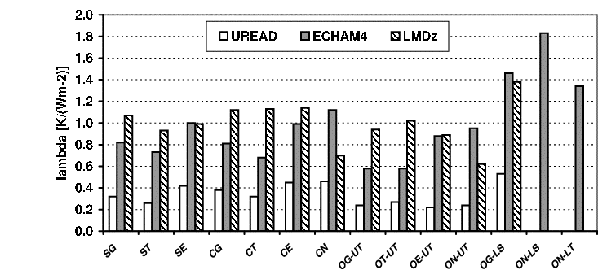
Figure 3.1 indicates the derived value of the climate sensitivity parameter; the meanings of the experiment labels are given under Task 3.1. By coincidence, the range of climate sensitivity parameters for global increases in CO₂ (experiment CG) amongst the three different GCMs spans the range from 0.38 to 1.1 K/(Wm⁻²), which is found in the wider community. This is of importance; we will be able to establish whether the dependence of λ on the nature of the forcing depends on a particular model's own absolute value of λ. It is clear from Figure 3.1 that the inter-model differences in λ are dominating over the difference between experiments, but nevertheless, there are indications that individual models are responding differently to different forcings – compare the variation of λ for example between experiments CG and ON-UT. If radiative forcing was a “perfect” metric of climate change, then λ should be independent of the experiment. The model results agree in indicating that this is not the case.
Figure 3.1: Climate sensitivity parameter λ in K/(Wm⁻²) for the GCM integrations using the idealised perturbations described under Task 3.1. The codes for these experiments are given there, but the final two columns are extra simulations performed by DLR. ON-LS is the lower stratospheric ozone perturbation restricted to northen extratropics, ON-LT is a lower tropospheric perturbation restricted to the northern extratropics

Figure 3.2 shows the normalised sensitivity parameter, which is the sensitivity of the model for a given experiment divided by the sensitivity for the “standard” experiment CG. The normalised sensitivity parameter shows the extent to which differences between experiments are consistent between the models, irrespective of the absolute size of λ. If there is a consistent pattern amongst the models such that certain climate change mechanisms are more or less effective than CG, then this could be used to improve the use of radiative forcing as a metric.

Figure 3.2 shows some encouraging features regarding the inter-model response. There is a general tendency for the models to be less sensitive to a solar forcing than carbon dioxide and more sensitive to extratropical forcings than tropical forcings; such responses have been reported elsewhere in the literature. More strikingly, the normalised sensitivities to upper tropospheric ozone changes are generally considerably lower than CG, whilst the sensitivity to stratospheric ozone changes is considerably higher than CG. In the case of tropospheric ozone, this has been shown to be due to a change in lapse rate, such that the upper tropospheric temperature change is much greater than in the CG and SG cases; this means that the surface temperature change required to achieve top-of-the-atmosphere radiation balance is less. In the case of stratospheric ozone, the increased sensitivity is mostly as a result of an accompanying increase in stratospheric water vapour, as had been previously reported by Stuber et al. (2001b).
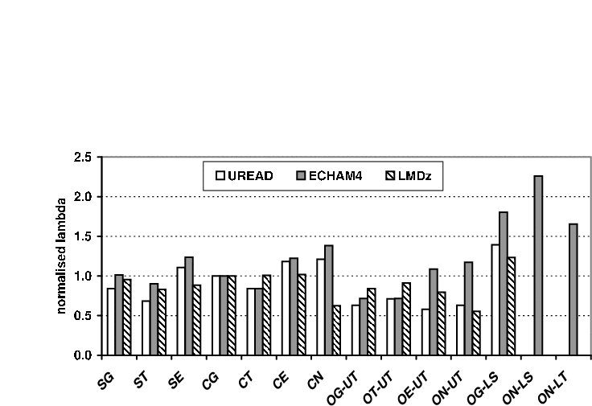
Figure 3.2: Normalised climate sensitivity parameter (each case in Figure 3.2 the climate sensitivity parameter is divided by the climate sensitivity parameter for the CG case) for the GCM integrations using the idealised perturbations described under Task 3.1. The codes for these experiments are given there, but the final two columns are extra simulations performed by DLR. ON-LS is the lower stratospheric ozone perturbation restricted to northen extratropics, ON-LT is a lower tropospheric perturbation restricted to the northern extratropics

However, Figure 3.2 also shows cases of disagreement amongst the models. For example, for OE-UT and ON-UT, the normalised sensitivity parameter for the DLR model is significantly higher than the other two models and the LMD model indicates a much-lessened sensitivity to extratropical forcings (see, for example, SE and CE) than the other two models. Although we have ideas for the causes of these differences (the reduced sensitivity of the LMD model to extratropical forcings is believed to be related to the form of the sea-ice parameterisation in that model) we believe that further work understanding these intermodel differences is important and will be described below in the plans and objectives for the next period.

Figure 3.3 shows the zonal mean surface temperature response for the CO₂ cases. This shows the degree to which the location of the forcing influences the meridional response profile. This is most marked in the extra-tropical NH case where most of the response is also in the northern hemisphere. Figure 3.3 emphasises the limitations of the global mean view given by the simple equation Compensation between radiative forcings of opposing signs at the global mean level does not necessarily imply compensation at the regional level.
ΔT = λ · RF.

As noted above, we remain concerned that we do not fully understand the causes of the inter-model differences, and this indicates that we need to be cautious about accepting the more positive indications that models possess a generic response to certain forcings. We have decided that more time should be spent on a climate feedback analysis of the runs already performed to ascertain whether there are consistent reasons for these inter-model differences. Such a feedback analysis will be performed in year 3, and will replace some work that we envisaged would be performed under Task 3.3.
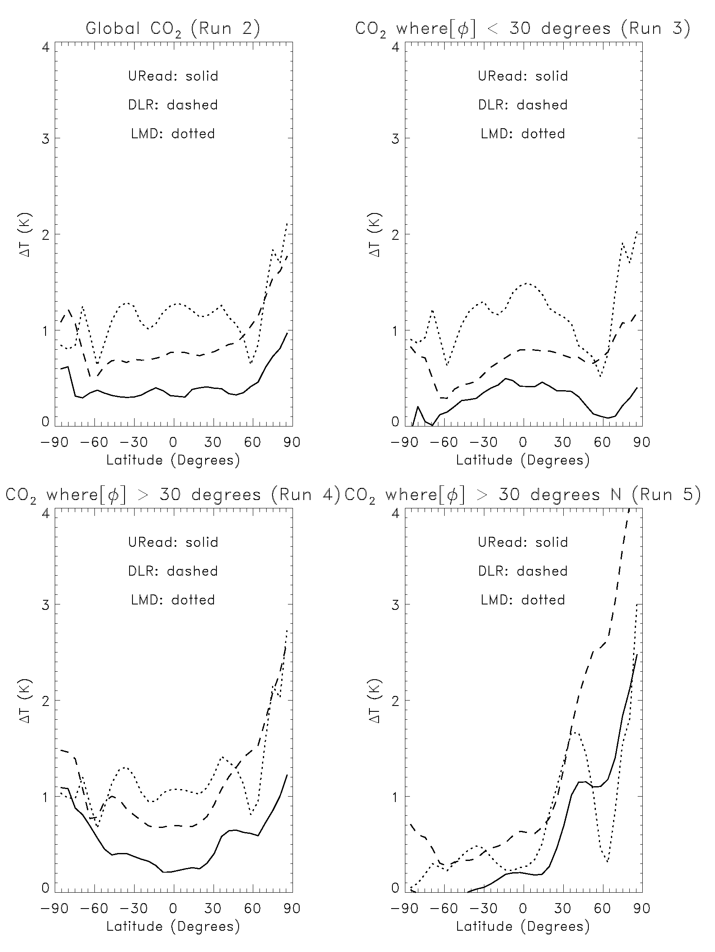

Figure 3.3: Zonal mean surface temperature change (in K) for the four CO₂ experiments using the three GCMs (DLR, LMD, and UREAD). Φ is the latitude.

Socio-economic relevance and policy implication

No direct socio-economic or policy implications are related to this work package.

Discussion and conclusion

The overall conclusion of the work under this task is that there is encouraging agreement between the models on the degree to which the global (and hemispheric) response depends on the geographical distribution of the forcing. It appears possible to improve the concept of radiative forcing and global warming potential (GWP). The precision with which forcings and GWPs can be compared may be improved by taking into account the nature of the individual forcing, by, for example, applying a simple weighting to each forcing.

However, there are a number of inter-model differences that indicate caution is necessary before generally applying such a weighting. We do not fully understand the causes of the inter-model differences and more analysis is required to establish these.

Plan and objectives for next period

It is intended that only one further set of perturbation experiments will be performed, to examine the difference in climate sensitivity parameter between global carbon dioxide changes and global methane changes. Methane is an important greenhouse gas, and possesses a significantly different latitudinal variation of forcing than carbon dioxide. These runs will be initiated and analysed in year 3.

Task 3.3 Simulations for realistic forcings

Objectives

The objective of Task 3.3 is to perform GCM simulations using realistic ozone perturbations using output from the CTMs described in Task 2.

Methodology and scientific achievements related to Task including contribution from partners

The three groups running GCMs are performing the experiments designed under Task 3.1: DLR, LMD (CNRS) and UREAD. The inter-model comparison is performed mainly at UREAD.

The methodology follows similar lines to that described in Task 3.2. For this case, the ozone perturbations provided by CICERO and CNRS-DR5 under Task 2.2 would give radiative forcings too small to generate a reliable climate change signal, so each group needed to scale the ozone changes to achieve a 1 Wm⁻² global-mean forcing in their model.

The experiments themselves, and the analysis of these, are underway and running to schedule. A preliminary view of the results is presented here, and restricted to the global mean case. Table 3.1 shows the climate sensitivity for those experiments that were completed at the end of year 2, together, for comparison purposes, with the sensitivity for the global CO₂ case (CG) from the idealised experiments. For all cases except the final column, the forcing applied was 1 Wm⁻²; for the final column, the ozone changes uses for the two CNRS-DR5 cases are added together – as the forcing is not strictly linear in ozone amount, the resulting forcings for this case were DLR: 1.86 Wm⁻², LMD: 1.9 Wm⁻², Reading: 1.86 Wm⁻².

Table 3.1: Climate sensitivity parameter (in K/(Wm⁻²)) for the 4 realistic ozone perturbation experiments described in Task 3.1. The global-mean CO₂ case is also shown for reference.

 | CO₂  (Case CG) | CNRS-DR5  NOx (Europe) | CNRS-DR5  NOx (Asia) | CICERO scenario NOx (Europe) | CNRS-DR5  NOx (Europe) plus NOx (Asia)
UREAD | 0.40 | 0.38 | 0.31
DLR | 0.81 | 1.15 | 0.90 | 1.20 | 1.00
LMD | 1.12 | 0.82 | 0.99 | 0.84

It is clear from this preliminary analysis that the models are not in agreement as to whether the sensitivity in the ozone cases is larger or smaller than CG; the results are nevertheless consistent with the idealised runs for extra-tropical tropospheric ozone perturbations (see Figure 3.2), where the UREAD and LMD models find a decreased sensitivity for ozone changes whilst DLR finds an enhanced sensitivity. A possible reason for this is that the ozone perturbations (especially the NOx (Europe) cases) are tending to increase the sensitivity due to a greater high latitude forcing, but decrease the sensitivity because of the general impact of tropospheric ozone forcings to decrease the lapse rate. The models then do not agree as to which of these two mechanisms dominates.

Discussion and conclusion

The results from these cases require further analysis before any firm conclusions can be drawn about the extent and causes of the inter-model differences.

Socio-economic relevance and policy implication

No direct socio-economic or policy implications are related to this work package.

Plan and objectives for next period

The immediate plans for this task is for all groups to complete their GCM integrations, and UREAD will then initiate a comparison on the same lines as Task 3.2. We envisage submitting the results for publication in conjunction the two groups providing the CTM output.

The next stage is to perform two further realistic cases, using ozone perturbations due to air traffic, which will be provided by the two CTM groups in year 3.

We have restricted the number of more realistic calculations because, as explained in Task 3.2, we believe there is a higher priority to understanding the detailed causes of the differences between the three GCMs via a feedback analysis.

WP 4 Existing metrics

Task 4.1 Review of available metrics

Objectives

The objective of this task is
- to review existing metrics of climate change.

Methodology and scientific achievements related to Task including contribution from partners

Based on an extensive literature review and our own research in this field we assessed the various existing metrics of climate change. The main focus was on radiative forcing (RF) and global warming potential (GWP) since these form the basis for present climate policy. GWPs and their application in policy making were debated, and several other alternative concepts were suggested by both natural and social scientists. There has been relatively little discussion of which purpose and functions alternative metrics serve, and which purpose and functions metrics of climate change should serve. We address the question of which functions metrics of climate change can serve, and which trade-offs that may be associated with alternative metrics. Our work gives an overview on how cost issues are dealt with, how gases are weighted against their climate impact (end point), and on the extent to which and how temporality is included, both with regard to emission control and with regard to climate impact. A list of criteria and “check points” was also developed. The question of purpose and function of the metrics is discussed in order to evaluate the metrics in this respect. The results of the literature review have been synthesized in Fuglestvedt et al. (2003). A summary is available as Fuglestvedt et al. (2002).

We evaluated how sensitive climate policy is to the use of various metrics. This is done with Norway as a case (Godal and Fuglestvedt, 2002): The comprehensive approach adopted in the Kyoto Protocol relies on the use of GWP calculated for a 100-year time horizon to convert emissions of various gases to “carbon dioxide (CO₂) equivalents”. This particular set of weights, or metric, has a limited capacity to handle the large variations in atmospheric adjustment times, and emissions of various gases that are equal in terms of “CO₂ equivalents” will not result in equal climatic effects. In this study, the 100-year GWP metric is assessed in the context of implementing the Kyoto Protocol. Using data from Norway, we explore how abatement policy formulated on the basis of 100-year GWPs compares to policies based on other metrics in terms of compliance costs and abatement profile, that is, the composition of the basket of gases reduced. We found that the costs for Norway change significantly when other metrics are used, but changes in the composition of the basket of gases are moderate. However, since compliance costs can be controlled through other mechanisms for post-Kyoto Protocols, the use of 100-year GWPs versus other metrics has little impact on the general formulation of Norwegian climate policy.

We tested how GWPs can be used in economic analyses of damages of climate change and the degree of equivalence that is obtained when damages of climate change are taken into consideration (Sygna et al., 2002). We look at the capacity of Global Warming Potentials (GWPs) to act as indicators of equivalence for temperature development and damage costs. We look at two abatement scenarios that are equivalent when using a 100-year GWP metric: one scenario reduces short-lived gases, mainly methane; the other scenario reduces CO₂. Model calculations show that, despite their equivalence in terms of CO₂ equivalents, the scenarios do not result in equal rates or levels of temperature change. The disparities become more prominent the further we move down the chain of consequences towards damage costs, measured either in respect to rate of climate change or level of climate change. Compared to the methane mitigation scenario, the CO₂ mitigation scenario showed present-value costs 1.3 and 1.4 times higher for level- and rate-dependent damage costs, respectively. This implies that the adequacy of using 100-year GWP as an index to reflect equivalent climate effects and damage costs from emissions is questionable. The conclusions were found to be robust when GWPs for other time horizons (20 and 500 years) were used in the tests of level and rate-dependent damage.

Figure 4.1: Temperature responses to changes in emissions of CO₂ and CH₄ in terms of CO₂ equivalents for various time horizons.

Socio-economic relevance and policy implication

The results from our studies are relevant for the assessment of the application of GWPs and other metrics in the formulation of climate policy and also in economic analyses of climate change. A commentary article about IPCC’s structure and work on metrics and GHG indices and the need for a multi-disciplinary approach to this issue was submitted (Godal, 2002).

Discussion and conclusion

We have gained a good overview of existing metrics of climate change and useful insight to the problems related to the various metrics; both in terms of scientific limitations and shortcomings, the problems related to their application and the formulation of metrics in light of what function and purpose they should serve. Our multidisciplinary approach (political science, economics, natural science) enables us to understand the different aspects of the various alternative metrics and how they may function in policy-making and in the development of climate regimes.

Plan and objectives for next period

All milestones and deliverables of this Task were achieved. The central paper (Fuglestvedt et al., 2002a) was submitted in December 2001. In addition to the original Description of Work we plan a potential further revision of our work by the end of 2002.

Task 4.2 Calculation of metrics

Objectives

The objective of Task 4.2 is
- to calculate the old metrics for the climate simulations of WP 3.

Methodology and scientific achievements related to Task including contribution from partners

We completed a FORTRAN program for routine calculation of GWPs for 88 gases for any chosen time horizon, and a set of GWPs was calculated.

No detailed documentation of the GWP values given by the IPCC in The Second Assessment Report (SAR) is, to our knowledge, available. This is remarkable since these GWP values form the basis for the implementation of the Kyoto Protocol. In Godal and Fuglestvedt (2002) we have given a quite detailed documentation of how these GWPs are calculated and which parameter values that are chosen (lifetimes, forcing parameters, concentrations, etc).

We also developed a method for relating GWPs for various time horizons (H) to metrics based on damage functions and discounting of future damages. These “backward calculations” give us insight to what the use of GWPs for the different gases and different time horizons means in terms of the nature and shape of the damage function and the rate for discounting future damages of climate change.

Socio-economic relevance and policy implication

It is important that it is possible to understand how the GWP values given by the IPCC are calculated and to reproduce these calculations. Thus, a clear and detailed documentation is required. This is not given by the IPCC, but the appendix in Godal and Fuglestvedt (2002) gives an outline of how the GWPs can be calculated in order to reproduce the values given by the IPCC. It also allows the calculation of GWPs for other time horizons or other choices of parameters or for updating the GWPs.

Our work on this Task has also formed the basis for several comments and input to the Third Assessment Report from the IPCC during the review process (Expert review and Government review).

Discussion and conclusion

M4.2 is delayed due to the late availability of the results from WPs 2 and 3.

Plan and objectives for next period
We plan to use input from WPs 2 and 3 to calculate a set of metrics. We have the tools ready to start the work in this WP as soon as the input is available. A set of metrics has been chosen for these calculations.

Task 4.3 Scientific evaluation of metrics

Objectives

The objective of this task is
- to evaluate the existing metrics from the view point of natural sciences.

Methodology and scientific achievements related to Task including contribution from partners

In this Task we have discussed for which climate parameter equivalence can be and should be expected (RF, integrated RF, ΔT, integrated temperature change, ΔSL, Damage (Euro), etc.).

A test was performed: The temperature effect (ΔT) of CO₂ equivalent reductions in emissions (15 years), implemented for CO₂ and methane using GWPs for time horizons of 20, 100 and 500 years has been calculated (Figure 4.1). Obviously there is no equivalence in ΔT, which is no surprise to climate scientists. but probably to policy makers and users from other disciplines. This may be a matter of communication about expectations.

Equivalence further down the cause-effect chain has been tested (Sygna et al., 2002). We use scenarios (from Fuglestvedt et al., 2000) that are equivalent based on 100-year GWPs:
- S1: CO₂ reductions
and
- S2: Reductions of short-lived gases (mainly CH₄)
The calculations (Table 4.1) show large differences in rates and levels of temperature change between the scenarios (i.e., no equivalence). Damage costs are calculated based on level of temperature change or rate of temperature change. Large disparities between the scenarios in terms of development of damage costs over time are found. This also holds for the calculation of present value.

Table 4.1: Ratio of present costs between scenarios S1and S2

 | Discount rates
 | 1% | 2% | 3% | 7% | 10%
Level dependence | 0.81 | 1.05 | 1.26 | 1.76 | 1.74
Rate dependence | 0.77 | 1.10 | 1.37 | 1.64 | 1.50

Level- and rate dependent damage cost functions were also used for scenarios that were equivalent based on GWPs for other time horizons, i.e. 20 and 500 years. It was found that the conclusions in the paper were also valid for these cases and not only for the GWP₁₀₀ case.

Socio-economic relevance and policy implication

The fact that emissions may be equivalent in terms of GWP but not in terms of other metrics like temperature change, rate of temperature change or damage costs, might have an impact on design and choice of metrics in a follow-up treaty to the Kyoto Protocol.

Discussion and conclusion

Emissions that are equal in terms of CO₂ equivalents will not produce equivalent climatic effects. The results from our work also imply that the adequacy of using GWP₁₀₀ as an index to reflect equivalent climate effects and damage costs from emissions is questionable. On the other hand, the limitations and inaccuracies in the GWP metric have to be weighted against the advantage of having transparent and simple tools.

Plan and objectives for next period

We plan to evaluate the metric calculated for the runs performed in WPs 2 and 3. We also plan to do a study in which we assess how various choices of metrics and GHGs indices affect the formulation of climate policy and its costs. This is a follow up to the paper by Godal and Fuglestvedt (2002).

WP 5 Refined metrics

Task 5.1 Development of refined metrics

Objectives

The objective of this task is
- to develop refined metrics of climate change.

Methodology and scientific achievements related to Task including contribution from partners

Based on the experience gained from WP 4 and the results of Task 3.2 several approaches towards refined metrics have been discussed.

According to WP 4, several different metrics with various key parameters (ΔT, ΔT/dt, ΔSL, etc.) can be constructed. Although a climate convention is established and a protocol for reductions of GHGs has been negotiated, there is so far no common conception or agreement regarding what aspects of climate change are most important. According to Article 2 of the UNFCCC, “the ultimate objective of the convention is to achieve stabilization of GHG concentrations in the atmosphere at a level that would prevent dangerous anthropogenic interference with the climate system.” A reasonable interpretation given the comprehensive approach principle in the Convention is that radiative forcing is to be stabilized at a level that prevents a dangerous interference with the climate system and that a suite of GHGs can be reduced according to the comprehensive approach to meet the forcing target. But since “dangerous” can be interpreted in several ways, this goal formulation does not provide any guide to evaluation criteria for existing metrics or for a new metric concept.

We conclude:
- The development of amendments to the Kyoto Protocol gives new opportunities for refined metrics.
- The existing GWP concept should not be considered as default.
- A clarification of requirements and evaluation criteria for development of refined indices is needed.
- We need to gain insight from the alternative approaches, i.e., a multi-disciplinary approach is necessary (not only based on natural science as in IPCC/WG I).
- GWP has limitations and inaccuracies, but is highly politically feasible. Any refined metric has to compete with this.
- It is necessary to increase adequacy by including additional RF agents and differences in the climate sensitivity parameter λ?
- An enhanced GWP concept may clear the path for climate policies that cover a larger part of the man-made RF, and thus improve mitigation in terms of comprehensiveness and cost efficiency.

Based on the results of Task 3.2 we are considering a modified radiative forcing RF* for inhomogeneously distributed forcing agents:
$\text{RF}∗ = \frac{λ}{λ_{\text{CO}2}} ⋅ \text{RF}$
where RF, λ and λ_{CO2} are the radiative forcing of given perturbation, the associated climate sensitivity parameter and the climate sensitivity parameter associated with a homogeneous CO₂ forcing. RF* could be considered as "equivalent radiative forcing".

A further idea is based on the concept of damage due to climate change. It is rather difficult, and subject of many political discussions, if damage is to be expressed in monetary terms. If we stay in the physical domain we might take global or local temperature change ot the rates of this changes as proxies for damage. We therefore define the Heteorogenoeus Damage Metric of the grad n (or the "Berntsen Index")

${\text{HDM}}_{i}^{n} = \frac{\int_{0}^{H}{\int_{\text{globe}}{{\left[{ΔT}_{i}(γ,ϕ,t)\right]}^{n}\text{dA} \text{dt}}}}{\int_{0}^{H}{\int_{\text{globe}}{{\left[{ΔT}_{\text{ref}}(γ,ϕ,t)\right]}^{n}\text{dA} \text{dt}}}}$ (*)

where ΔT(ϕ,γ,t) is the change of the (near) surface temperature as function of geographical longitude ϕ, geographical latitude γ and time t. i and ref are the indeces of the considered climate change agent and reference agent (e.g., CO2). H is the considered time horizon. In the case n = 1, only the global mean temperature change detemrines the result. In the case n > 1, a locally stronger temperature change receives a higher weight than locally small changes. This reflects the fact that in many cases damages increase stronger than linear with temperature change.

If in (*) ΔT is replaced by $\frac{∂ΔT}{∂t}$ the rate of temperature change is considered as the crucial impact parameter, instead of the change itself.

Socio-economic relevance and policy implication

A refined metric may have an impact on future climate negotiations.

Discussion and conclusion

So far on preliminary studies have been made.

Plan and objectives for next period

Further approaches towards refined metrics will be made.

Task 5.2 Application of refined metrics

This Task has not yet been started.

Plan and objectives for next period

We plan to calculate the refined metrics for the climate simulations of WP 3.

Task 5.3 Scientific evaluation of metrics

This Task has not yet been started.

Plan and objectives for next period

We plan to evaluate the refined metrics from the view point of natural sciences.

WP 6 Political evaluation of metrics

Task 6.1 Political requirements

Objectives

The objective of Task 6.1 is
- to discuss and formulate requirements for climate metrics to be applicable by policy makers, both as a tool for decision making and as a tool for generating environmentally adequate solutions.

Methodology and scientific achievements related to Task including contribution from partners

Metrics for comparing GHGs should not only be evaluated in terms of their scientific robustness and performance, but should also be evaluated in terms of their political applicability. At a general level, the political applicability of an index or methodology for the comparison of different GHGs can be evaluated in terms of at least four main functions, which all prompt different requirements to the metric. Whereas the first three of these functions (see also Skodvin and Fuglestvedt, 1997) relate to the scientific quality of the metric in question, the latter relates to the applicability of different kinds of metrics in a specific policy context:
- The methodology or index should serve as a tool for communication between scientists and policy makers. This function primarily prompts one requirement, namely simplicity.
- It should serve as a tool for decision-making. This prompts at least two requirements: That it can be employed by policy makers in relative independence of scientific input, and that policy makers can employ the metric in confidence of its scientific quality. This essentially implies that the metric, to the extent possible, should be scientifically uncontroversial. While scientific agreement regarding the quality of the metric certainly does not guarantee political agreement on policy decisions, scientific controversy regarding this aspect could hamper political decision-making to the extent that the metric in practice becomes inapplicable as a tool for decision-making.
- The metric should be flexible in the sense that new knowledge can be incorporated as it is developed. This is not only a requirement to the metric itself, but also to the policy framework within which the metric is applied.
- Perhaps encompassing all of the above, the metric should be evaluated in terms of the extent to which it will allow for future policy options otherwise not available. The adequacy to apply any enhanced or new metrics of climate change will depend on which policy context evolves: the major lines of debate and conflict in the international negotiations will determine the political needs that an enhanced or new metric has to serve. Depending on the negotiation context, it might be necessary to have different elaborated metrics available in order to push the negotiations further. Hence, the assessment of metrics has to consider different options of future developments in the climate regime in order to assess a variety of likely policy options and related metrics.

Methodological issues

In WP 6.1, several approaches to the objectives are applied:
- Literature review (role of scientific and policy making models) and own analysis of climate negotiations focusing on
- the political discussion and adoption of commitments for Annex I Parties and their relevance regarding the choice of metrics,
- GWP as a decision making tool in order to implement the „comprehensive approach“,
- proposals of Parties currently discussed and implications for the political adequacy of metrics in specific negotiation contexts.
- the evolution of climate negotiations themselves as well as lines of arguments and conflicts respectively that might form driving forces or obstacles to the further development of the climate regime.
- Legal text review (Kyoto Protocol, Marrakech Accords) to distinguish between the different functions and political needs that metrics of climate change have to fulfil.
- Interviews which are held with experts in international climate change negotiations and multilateral environmental agreements (MEA) in general.
- A review of the design and application of metrics in other MEAs. Background: interview partners indicated that the climate negotiations would considerably profit from the experiences with metrics in other MEA. Two regimes considered are the stratospheric ozone regime and the LRTAP regime (Long-Range Transboundary Air Pollution).

Achievements

A draft working paper on „Political requirements of metrics of climate change“ has been developed. Two basic categories of requirements have been distinguished: First, those that stem directly from legal texts (UNFCCC, the Kyoto Protocol), and second, those procedural ones that may be derived from the negotiation context. Generally, environmental and political effectiveness are criteria for successful negotiations and decision-making. Negotiation processes are regularly confronted with tensions and trade-offs between these two criteria. As regards revised or new metrics of climate change, effectiveness can be interpreted as follows:
- Environmental effectiveness: find a metric that is the adequate instrument regarding the ultimate goal of the climate regime and its more specific commitments (scientific criterium).
- Political effectiveness: find a metric that is the adequate instrument regarding the generation of successful negotiations and political decision making, which means it allows to mobilise sufficient political support to generate agreement in a suitable tailored political process (political criterium).
This implies that „adequacy“ is a central issue. Whether a metric is adequate or not, depends on both of criteria. Hence, both, metric and political process have to be judged together.

Based on the assessment of legal text and procedures, a working list of political requirements was developed, building on the work of Skodvin and Fuglestvedt (1997) and Fuglestvedt et al. (2002).

Regarding the legal text requirements three functions of metrics are particularly relevant:
- Scientific assessments:
- Definition of the ultimate objective in Art.2 UNFCCC.
- Review adequacy of measures taken and of compliance with regard to commitments.
- Negotiations:
- Enable for the implementation of the comprehensive approach.
- Enable for the inclusion of other than the „Kyoto basket greenhouse gases“.
- Enable for burden sharing.
- Flexibility in implementation:
- Provide transfer prices.
- Enable for the application of instruments (flexible mechanism, trading).

Regarding the procedural requirements at least three categories have to be considered:
- Simplicity and transparency: The metric should be easily to understand and to use.
- Flexibility: The methodology should be open to advancements in scientific knowledge and to changes in the negotiation process.
- Political feasibility: Uncertainties should be reduced to the maximum extent possible.
- Enable for conflict resolution (political deadlock situations): Political conflicts may be solved by the application of a new metric opening up new policy options for the further development of the climate regime

The draft working paper has been revised particularly with respect to the climate negotiation context in order to cover the obstacles and driving forces of and to identify the political needs in present climate negotiations. A short review of the relevance of the metrics discussed in WP 4.1 has been integrated.

A second working paper has been developed which focuses on the interdependence of the applicability of metrics and the potential future options for a development of the climate regime. The policy options have been discussed for the cases of integrating stratospheric ozone and emissions from aviation into the climate regime.

Socio-economic relevance and policy implication

Task 6.1 generates background material that is used in Task 6.2 and later for the assessment of new or refined metrics of climate change. The preliminary checklist to assess the political applicability of any metric of climate change already provides important insights in how metrics might be further developed in the climate negotiations.

The analysis of the negotiation context and discussion of several development options of the climate regime prepares for the general assessment of the political applicability of different types of metrics of climate change.

Discussion and conclusion

An important result is the recommendation that a more thorough assessment of the design and use of metrics in other than the climate regime would be extremely fruitful. In particular, experiences with the role that the RAINS-model, an “Integrated Assessment Model”, played in the negotiations for the Gothenburg Protocol appeared to be helpful for understanding the particular circumstances under which metrics are more or less useful in environmental regimes. This investigation aims at improving the applicability of any enhanced or new metric under the climate regime, in particular in two respects: first, with respect to the procedural requirements related to existing commitments in the climate regime, and second, with respect to the role that metrics may play for the further development of the climate regime. A first but short overview on the ozone and LRTAP regime with regard to the metrics and decision-making tools applied has been elaborated. As a conclusion from these works, three concepts of how metrics fulfil their functions in multilateral environmental regimes are distinguished.

Plan and objectives for next period

The working paper for WP 6.1 will be submitted to the journal “Climate Policy”.

Task 6.2 Evaluation of existing metrics

Objectives

The objectives of this task are
- to assess existing metrics according to requirements formulated in 6.1;
- to compare alternative existing metrics with respect to their capacity to serve these functions;
- to evaluate alternative existing metrics in terms of the extent to which they are associated with a trade-off between scientific accuracy and political applicability and feasibility;
- to evaluate existing metrics in terms of the extent to which they serve to include or exclude policy options.

Methodology and scientific achievements related to Task including contribution from partners

Methodological issues

WP 6.2 basically relies on a review of available metrics and their scientific evaluation (from WP 4) and the list of requirements (from Task 6.1).

Achievements

Work on Task 6.2 concentrated on an assessment of the currently used metrics CO₂ equivalents and GWP and metrics suggested in WP 4.1 on the basis of the evolving list of political requirements from WP 6.1. The results of this assessment have been integrated in the working paper resulting from Task 6.1.

The inclusion of a new Task had been decided at the end of the previous reporting period. The objective of the new task is to assess the role and application of metrics in other environmental regimes in order to integrate a greater amount of political experiences with metrics in multilateral environmental regimes. A first draft working paper has been developed.

Socio-economic relevance and policy implication

The assessment provides a policy relevant evaluation of existing metrics, notably the GWP methodology, as compared to more sophisticated metric concepts according to requirements formulated in 6.1. More sophisticated metric concepts means that the space on which the metric is defined is enlarged in order to cover socio-economic assessments. This provides input for the climate negotiations, as methodological issues are currently on the Agenda of the Subsidiary Body on Scientific and Technological Advice (SBSTA). Furthermore the inclusion of other than the six „Kyoto basket“ source gases will be a prominent issue in the climate negotiations not least subsequent to the fundamentally altered positions of the USA.

Discussion and conclusion

The assessment of metrics of climate change shows that the differentiation of functions suggested in Task 6.1 which metrics of climate change have to fulfil leads to the conclusion that a phased approach to metrics of climate change is expected to be fruitful: depending on the function (for scientific assessments, negotiations or trading), different metrics may be most adequate. Or, depending on the functions, it might be most adequate to consider the choice of metrics within the specific negotiation context. Whereas an improvement of the currently used metrics might be adequate for the implementation of the existing provisions and commitments under the climate regime, the application of more sophisticated metrics of climate change may be adequate under specific negotiation situations.

Plan and objectives for next period

The results of Task 6.2 were integrated in the working paper resulting from Task 6.1 to be submitted for publication.

It is planned to present the results of Tasks 6.1 and 6.2 in a side meeting to the climate negotiations on occasion of COP 8.

Task 6.3 Evaluation of refined metrics

This Task has not yet been started.

Plan and objectives for next period

We plan
- to assess refined metrics according to requirements formulated in 6.1;
- to compare alternative refined metrics (and existing metrics) with respect to their capacity to serve these functions;
- to evaluate alternative refined metrics in terms of the extent to which they are associated with a trade-off between scientific accuracy and political applicability and feasibility;
- to evaluate refined metrics in terms of the extent to which they serve to include or exclude policy options.

Task 6.4 Overall evaluation

This Task has not yet been started.

Plan and objectives for next period

We plan to perform an overall evaluation of the metrics, both existing and refined (jointly from the view points of natural sciences, economics and political science).

WP 7 Publications

Objectives

The objectives of this WP are
- to publish results in scientific journals, in reports more accessible to policy makers, and on the internet;
- to publish selected model output on the internet.

Methodology and scientific achievements related to Task including contribution from partners

During the first two years of the METRIC project 12 peer reviewed papers on the topics of METRIC have already been published by the partners or are in the review/print process. Various presentations have been made in conferences, workshops or seminars. The web site has been further developed (http://www.pa.op.dlr.de/metric/metric.html).

Furthermore, the participants have been Contributing Authors and Reviewers to Chapter 4 (Atmospheric Chemistry and Greenhouse Gases) and Chapter 6 (Radiative Forcing of Climate Change) of the IPCC Third Assessment Report. One participant is also a co-authors of the WMO/UNEP Scientific Assessment of Ozone Depletion: 2002, in the chapter relating to climate impacts of ozone changes.

Publications in peer reviewed journals

- Clerbaux, C., J. Hadji-Lazaro, D. Hauglustaine, G. Mégie, B. Khattatov and J.-F. Lamarque, 2001: Assimilation of carbon monoxide measured from satellite in a three-dimensional chemistry-transport model, J. Geophys. Res. 106, 15,385-15,394.
- Fuglestvedt, J.S., T.K. Berntsen, O. Godal, R. Sausen, K.P. Shine and T. Skodvin, 2003: Metrics of climate change: Assessing radiative forcing and emission indices. Climatic Change. Climatic Change, in press.
- Godal, O. and J. Fuglestvedt, 2002: Testing 100-year global warming potentials: Impacts on compliance costs and abatement profile. Climatic Change 52, 93-127.
- Godal, O., 2003: The IPCC’s assessment of multidisciplinary issues: The case of greenhouse gas indices. Climatic Change, in press.
- Hauglustaine, D., L. Emmons, M. Newchurch, G. Brasseur, T. Takao, K. Matsubara, J. Johnson, B. Ridley, J. Stith, and J. Dye, 2001: On the role of lightning NOx in the formation of tropospheric ozone plumes: a global model perspective, J. Atmos. Chem. 38, 277-294.
- Hauglustaine, D. A. and G. P. Brasseur, 2001: Evolution of tropospheric ozone under anthropogenic activities and associated radiative forcing of climate, J. Geophys. Res. 106, 32,337-32,360.
- Joshi, M. and K. Shine, 2003: A GCM study of volcanic eruptions as a cause of increased stratospheric water vapour, Submitted to J. Clim..
- Joshi, M., K. Shine, M. Ponater, N. Stuber, R. Sausen and L. Li, 2003: A comparison of climate response to different radiative forcings in three general circulation models: towards an improved metric of climate change. Climate Dyn., in press.
- Jourdain, L. and D. A. Hauglustaine, 2001: The global distribution of lightning NOx simulated on-line in a general circulation model, Physics and Chemistry of the Earth (C) 26, 585-591.
- Stuber, N., R. Sausen and M. Ponater, 2001a: Stratosphere adjusted radiative forcing calculations in a comprehensive climate model. Theor. Appl. Climatol. 68, 125-135.
- Stuber, N., M. Ponater and R. Sausen, 2001b: Is the climate sensitivity to ozone perturbations enhanced by stratospheric water vapor feedback? Geophys. Res. Lett. 28, 2887-2890
- Sygna, J.S. Fuglestvedt and Aaheim, 2002: The adequacy of GWPs as indicators of damage costs incurred by global warming. Mitigation and Adaption Strategies for Global Change 7, 45-62.

Further publications

- Berntsen, T.K., J.S. Fuglestvedt, M. Joshi, K.P. Shine, M. Ponater, R. Sausen and D. Hauglustaine, 2002: Indirect forcings from emissions of NOx and CO: Is the location of emissions important? In J. van Ham, A.P.M. Baede, R. Guicherit and J.G.F.M. Williams-Jacobse (eds.): Non-CO2 Greenhouse Gases: Scientific Understanding, Control Options and Policy Aspects. Millpress, Rotterdam, Netherlands, ISBN 90-77017-70-4, 363-369.
- Fuglestvedt, J.S., 2000: Looking for a better way to measure the effects of GHGs: CICERO in a new EU project to refine GWPs and radiative forcing Cicerone 1/2000. http://www.cicero.uio.no/cicerone/00/1/en/jansf2.pdf
- Fuglestvedt, J.S., O. Godal, T.K. Berntsen, T. Skodvin, K.P. Shine and R. Sausen, 2002: The adequacy of current metrics of climate change and emission indices. In J. van Ham, A.P.M. Baede, R. Guicherit and J.G.F.M. Williams-Jacobse (eds.): Non-CO2 Greenhouse Gases: Scientific Understanding, Control Options and Policy Aspects. Millpress, Rotterdam, Netherlands, ISBN 90-77017-70-4, 389-394.
- Fuglestvedt J. S., T. Berntsen, O. Godal, R. Sausen, K.P. Shine, and T. Skodvin, 2001: Assessing metrics of climate change: Current methods and future possibilities. Report 2001-04. CICERO, 51pp.
- Godal, O. and J.S. Fuglestvedt, 2001: Does the choice of metric affect abatement strategy? Cicerone, 2002 (1). http://www.cicero.uio.no/media/1726.pdf
- Luhmann, H.-J., 2002: Review of: Schwarze, Reimund: Internationale Klimapolitik. (Ökologie und Wirtschaftsforschung , Bd. 39). Marburg 2000. Natur und Recht 24 (3), 186-187.
- Luhmann, H.-J., 2002: Das Beispiel Ozonloch. Zwei unausgeschöpfte Lehren eines politischen Erfolgs.Naturwissenschaftliche Rundschau 55 (9), 483 488.
- Luhmann, H.-J., 2002: Interessen und Solidarität in der Klimafrage – hoffnungslos asymmetrisch? Vermächtnis an Deutschland als ein Pionier der industriellen Entwicklung. In: BUND (Hg.): Reiseführer Zukunftsfähiges Deutschland. (in press).
- Sausen, R., M. Ponater, N. Stuber, M. Joshi, K. Shine and L. Li, 2002: Climate response to inhomogeneously distributed forcing agents. In J. van Ham, A.P.M. Baede, R. Guicherit and J.G.F.M. Williams-Jacobse (eds.): Non-CO2 Greenhouse Gases: Scientific Understanding, Control Options and Policy Aspects. Millpress, Rotterdam, Netherlands, ISBN 90-77017-70-4, 377-381.

Oral presentations

- Aaheim, H.A., J.S. Fuglestvedt and O. Godal: The Cost of Global Warming Potentials. Energy Modelling Forum 21, Multi-gas Mitigation and Climate Change, Washington DC, USA, 04-06 December 2002.
- Berntsen, T.K., J.S. Fuglestvedt, M. Joshi, K.P. Shine, M. Ponater, R. Sausen and D. Hauglustaine: Indirect forcings from emissions of NOx and CO: Is the location of emissions important? Third International Symposium on Non-CO₂ Greenhouse Gases (NCGG-3), Maastricht, The Netherlands, 21.-23.1.2002.
- Clerbaux, C., J. Hadji-Lazaro, D. Hauglustaine, G. Mégie, B. Khattatov and J.-F. Lamarque, Assimilation of CO from IMG/ADEOS observations, EGS, Nice, 2001.
- Clerbaux C., J. Hadji-Lazaro, S. Turquety, D. Hauglustaine, C. Granier et G. Mégie, Tropospheric measurements from nadir-viewing infrared instruments, Workshop on Emissions of chemical species and aerosols into the atmosphere, Paris, June 2001.
- Fuglestvedt, J., O. Godal, T. Berntsen, T. Skodvin, K. Shine and R. Sausen: The adequacy of current metrics of climate change and emission indices. Third International Symposium on Non-CO₂ Greenhouse Gases (NCGG-3), Maastricht, The Netherlands, 21.-23.1.2002.
- Godal, O. and J. Fuglestvedt: Testing 100-year Global Warming Potentials: Impacts on compliance costs and abatement profile. Joint meeting: Energy Modelling Forum & Multi-gas Working Group (organized by US EPA, IEA GHG and EC), Maastricht, The Netherlands, 24 January 2002.
- Hadji-Lazaro J., C. Clerbaux, S. Turquety, D. Hauglustaine and B. Khattatov: Trace gases concentrations retrieval from measurements provided by a nadir looking FTS, SPIE Annual meeting, San Diego, USA, July 2001.
- Hauglustaine, D.: NOx-NOy modeling in the upper troposphere, Workshop on nitrogen oxides in the lower stratosphere and upper troposphere, Heidelberg, March 2001.
- Hauglustaine, D., L. K. Emmons, M. Newchurch, and G. Brasseur, On the role of lightning NOx in the formation of tropospheric ozone plumes, EGS, Nice, 2001.
- Joshi, M., E. Highwood and K.P. Shine: Radiative forcing, climate sensitivity and the tropopause. AGU 2000 Fall Meeting, San Fransisco, USA, 7-13 December 2000.
- Jourdain, L., D. Hauglustaine, F. Hourdin, and F. Lott: Ozone and its precursors in the lower stratosphere and upper troposphere simulated intercatively in the LMDz general circulation model, EGS, Nice, 2001.
- Jourdain, L., and D. Hauglustaine: Impact of lightning NOx on the distribution of tropopheric ozone, IAMAS, Vienne, 2001.
- Ponater, M.: Klimawirkung von Spurengasen – Möglichkeiten und Grenzen des “radiative forcing”-Konzeptes, Colloquium of the Meteorological Institute of the Munich University (LMU). 23.1.2001 (invited).
- Ponater, M.: Radiative Forcing – ein verlässlicher Parameter zur Klimavorhersage ?, German-Austrian-Swiss meteorological congress (DACH-Meteorologentagung). Wien, Austria, 18.-21.9.2001.
- Ponater, M., M. Dameris, N. Stuber, C. Schnadt, R. Hein, and B. Steil: On the contribution of ozone and stratospheric water vapour to the global warming, EGS XXVI General Assembly, Nice, France. 25.-30. March 2001.
- Sausen, R., N. Stuber and M. Ponater: Climate response to inhomogeneously distributed forcings. Seminar at the Department of Earth System Sciences, University of California, Irvine, USA, 2.5.2001.
- Sausen, R., N. Stuber and M. Ponater: Climate response to inhomogeneously distributed forcings. Seminar at the SCRIPPS Institution of Oceanography, La Jolla, CD, USA, 5.6.2001.
- Sausen, R.: Die Antwort der Atmosphäre auf räumlich inhomogen verteilte Störungen. Kolloquium des Instituts für Chemie und Dynamik der Geosphäre, Teilinstitut Stratosphäre, Forschungszentrum Jülich, 9.6.2001.
- Sausen, R., N. Stuber and M. Ponater: Climate response to inhomogeneously distributed forcings. Seminar at the Program for Climate Model Diagnostics and Intercomparison (PCMDI), Lawrence Livermore National Laboratory (LLNL), Livermore, USA, 24.6.2001.
- Sausen, R., M. Ponater, N. Stuber, M. Joshi, K. Shine and L. Li: Climate response to inhomogeneously distributed forcing agents. Third International Symposium on Non-CO₂ Greenhouse Gases (NCGG-3), Maastricht, The Netherlands, 21.-23.1.2002.
- Sausen, R.: The response of the atmosphere to inhomogeneously distributed forcings (invited). Colloquium at KNMI, Bilthoven, The Netherlands, 24.1.2002.
- Sausen, R.: Reagiert die Atmosphäre anomal auf inhomogen verteilte Störungen? (invited) Vortragsveranstaltung im Forschungszentrum Karlsruhe,8.3.2002.
- Sausen, R.: Reagiert die Atmosphäre anomal auf inhomogen verteilte Störungen? (invited) Vortragsveranstaltung im Forschungszentrum Karlsruhe,8.3.2002.
- Sausen, R.: Unsicherheitsanalysen: Warum sind die Fehlerbalken so groß? (invited). 3. Deutscher IPCC-Strategie-Workshop, Bad Münstereifel, 27. - 28.05.2002.
- Sausen, R.: Reagiert die Atmosphäre anomal auf inhomogen verteilte Störungen? (invited) Oberseminar, Freie Universität Berlin, Fachbereich Mathematik und Informatik, Numerical Analysis / Scientific Comupting, Berlin, 25.10.2002.
- Shine, K.P.: Radiative Forcing of Climate Change: The certainties and uncertainties. Seminar at Department of Chemistry, University of Cambridge, 5 June 2001.
- Shine, K.P.: Climate effects of methane – Cut sooner of Cut Later? Oxford, to the Green College Centre for Environmental Policy and Understanding, February 2002.
- Shine, K.P.: How good is radiative forcing as an indicator of climate change? To the Royal Meteorological Society Wednesday Meeting, Radiative Forcing of Climate Change, February 2002.
- Skodvin, T.: Making climate change negotiable: The development of the global warming potential index. Worlds in Transition: Technoscience, Citizenship and Culture in the 21st Century. Conference co-sponsored by the Society for the Social Studies of Science (4S) and The European Association for the Study of Science and Technology (EASST). Wien, Austria, 27.-30.9.2000.
- Stuber, N., M. Ponater, and R. Sausen: Enhanced climate sensitivity due to stratospherice water vapour feedback ?, EGS XXVI General Assembly, Nice, France. 25.-30.3.2001.
- Stuber, N., M. Ponater, and R. Sausen: Enhanced climate sensitivity due to stratospherice water vapour feedback ?, IAMAS congress, Innsbruck, Austria, 10.-18.8.2001.

Poster presentations

none.

5. Annex

Annex 2.1 CTM descriptions

LMDzT-INCA

INCA (Interactions with Chemistry and Aerosols) is an new emission/chemistry model coupled to the LMDzT (Laboratoire de Météorologie Dynamique) general circulation model. LMDzT-INCA accounts for emissions, transport (resolved and sub-grid scale), photochemical transformations, and scavenging (dry deposition and washout) of chemical tracers interactively in the GCM. Several versions of the INCA model are currently used depending on the envisaged applications. The standard model resolution is 3.75x2.5 degrees with 19 sigma-p hybrid levels. The GCM also offers the possibility to zoom over specific regions, reaching typical horizontal resolutions of 50x50 km². The numerics used to solve the time evolution of chemical species is based on a pre-processor. The model can be run in a nudged mode, relaxing to ECMWF winds and temperature. An off-line version of the GCM has also been developed in order to minimize the required computing time for transport simulations. This model is still under development and constitutes the atmospheric component of the IPSL coupled atmosphere-ocean-biosphere model.

Photolysis rates in INCA are determined based on a pre-calculated multiple entry look-up table. This table is generated using version 4.01 of the Tropospheric Ultraviolet and Visible (TUV) model. The pseudo-spherical discrete ordinates method has been used. The photorates are tabulated for 8 solar zenith angles, 7 ozone columns, 4 surface albedos, 3 temperatures at 500mb, and 2 temperatures at 200 mb. The j values are then multi-interpolated on-line depending on local conditions prevailing in the gridcell and corrected for the effect of cloud cover and optical depth as calculated by the GCM.

Surface emissions of precursors and in-situ aircraft emissions are prepared based on emission inventories using the INCAsflx pre-processor. This processor collects the various emissions on different resolutions, interpolates on the GCM horizontal grid, allows for re-scaling of global inventories if needed, and generates a netCDF input file for INCA with monthly mean emissions.

Lightning NOx emissions are calculated in the GCM based on empirical parameterizations. At each time step these emissions are recalculated interactively and show a strong seasonal and diurnal cycles (Jourdain and Hauglustaine, 2001).

OSLO CTM2

The OSLO-CTM2 is a global 3-dimensional chemical transport model that uses pre-calculated fields of winds and other physical parameters to simulate the chemical turnover and distribution of chemical species in the troposphere (Sundet, 1997). The meteorological input data for the model have been generated specifically for this model by running a series of 36 hours forecasts, with the ISF model at the ECMWF at T63 resolution for the year 1996. A new forecast is started every 24 hours from the analysis, allowing 12 hours of spin-up. An extensive set of data is sampled every three hours, including convective mass fluxes, which is not a part of the standard ECMWF archives. Also the temporal resolution (3 hours) is better than the standard ECMWF archives which uses 6 hours. The CTM can be run variable resolution up to T63 (1.87° x 1.87°), however, to limit the amount of CPU-time needed, in this study a horizontal resolution of T21 (5.6° x 5.6°) is used. The vertical resolution is also determined by the input data and the current model version includes 19 levels from the surface up to 10 hPa.

The advection of chemical species is calculated by the Prather scheme, a second order moment method (Prather, 1986). Convection is based on the Tiedtke (1987) mass flux scheme, where vertical transport of species is determined by the surplus or deficit of mass flux in a column. A comprehensive chemical scheme, including NMHC chemistry, is used. It includes 55 chemical compounds and 120 gas phase reactions in order to describe the photochemistry of the troposphere (Berntsen and Isaksen, 1997; Berntsen and Isaksen, 1999). The scheme is solved using the quasi-steady state approximation (QSSA). Photodissociation rates are calculated on-line, following the approach described in Wild et al. (2000). NOx emissions from lightning are coupled on-line to the convection in the model using the parameterisation proposed by Price and Rind (1993) and the procedure given by Berntsen and Isaksen (1999). Mixing in the planetary boundary layer is treated according to the Holtslag K-profile scheme (Holtslag et al., 1990). Influence of stratospheric ozone is estimated using a synthetic ozone approach where the ozone flux from the stratosphere is prescribed, but the model transport generates an ozone distribution that varies with time and space.

Annex 2.2 Protocol for model simulations based on IPCC intercomparison.

BOUNDARY CONDITIONS

FIXED GASES based on 1998 values: CH₄ and N₂O

CH₄: Global mean = 1745 ppbv, assume NH=1790 and SH=1700 ppbv. Choose a reasonable stratospheric profile based on your model.
N₂O: global mean = 314 ppbv (should not impact these calculations)
CO₂: global mean = 365 ppmv (should not impact these calculations)

SURFACE DEPOSITION: O₃

We are interested in the modeled O₃ distribution, and thus it is recommended that all participants use as-similar-as-possible surface "deposition velocities" for this species:

For O₃: Land (0.60 cm/s), Sea (0.00 cm/s), Poleward of 60 dgrees (0.00 cm/s)

Other wet and dry deposition rates up to individual participants.

EMISSIONS-BASED GASES: NO_{x}, CO, NMHC

The year-2000 emissions data set considers separate source categories per component based on existing standards or an extrapolation of EDGAR data (1x1 degree inventory). The interpolation to model grid is the responsibility of the participant.

Summary of Year-2000 emissions of NO [Tg N]:

Industry = fossil & bio fuels (~30 + 1.8) | 31.8
BB = savannah & ag-waste burning/deforest (3.2+1.2+2.7) | 7.1
Aircraft ANCAT 2000 | 0.6
Soils | 5.5
Lightning | 5.0
TOTAL | 50.0

Fossil fuel/industrial and biofuel emissions (IND). These emissions are provides as aggregated 1x1 gridded emissions. Assume no seasonal dependence.

Aircraft emissions (AV). ANCAT emissions updated for 2000 conditions.

Biomass burning emissions (BB). Use the model emissions for seasonal and geographical distributions and normalize to the global-annual value.

Soil emissions. Use the geographical and temporal distribution of soil emissions specified by Yienger and Levy (1995) of 5.5 Tg N for 1990; or use your model emissions scaled to 5.5 Tg(N)/yr.

Lightning. Scale your model lightning NO_{x} to 5 Tg(N)/yr.

Stratospheric influx. Models should use their own current method.

Summary of Year-2000 emissions of CO [Tg CO]:

Industry = fossil fuel/domestic burning | 650
BB = deforestation/savannah burning/waste burning | 700
BIO = vegetation (150) + oceans (50) | 200
SUB-TOTAL | 1550

(If the model do not account for NMHC use the following CO production)

CH4 oxidation | 800
Isoprene oxidation | 165
Terpene oxidation | Included in BIO
Industrial NMHC | 110
Biomass burning NMHC oxidation | 30
Acetone oxidation | 20
TOTAL (including model derived emissions) | 2675

Fossil fuel/domestic burning (IND). Gridded 1x1 industrial source supplied. Assume no seasonality.

Vegetation & ocean (BIO). Gridded 1x1 emissions are supplied. The vegetation 150 Tg CO includes potential terpene source. The oceanic 50 Tg CO is consistent with Bates.

Deforestation/savannah burning/waste burning (BB). Model emissions scaled to global-annual value.

The other components of the CO budget need to be calculated internally to each model. We include some approximate numbers above for reference. If possible, please try to keep your total CO sources close to this approximate budget. A CO yield of 35 % C/C per molecule of hydrocarbon oxidized is assumed for isoprene and industrial/biomass-burning NMHC in these estimates.

If NMHC are considered in the simulation:

Summary of Year-2000 emissions of NMHC [Tg C]:

Industry = fossil fuel/domestic burning | 161
BB = deforestation/savannah & waste burn | 34
Isoprene | 220
Terpene | 127
Acetone | 30
Total | 572

Fossil fuel/domestic burning (IND). A 1x1 EDGAR-based set of gridded emissions is provided along with NMHC breakdowns into 24 compounds/classes. It includes sectors such as power generation, industry, fossil fuel production.

Deforestation / savannah burn / waste burning (BB). A 1x1 EDGAR-based set of gridded emissions is provided along with NMHC breakdowns into 24 compounds/classes. Apply same seasonality as for biomass burning NO_{x}.

Isoprene. Total is based on Hauglustaine & Brasseur work. For gridded emissions use the GEIA data of Guenther et al (1995) scaled to 220 Tg C (i.e., by 43.7%).

Terpenes. Use the GEIA recommendations.

Acetone. Rough estimate is based on Singh et al. Models should use their own distributions if this source can be included.

STRATOSPHERE:

It is impossible to specify a consistent stratosphere for the range of 3-D models involved in tropospheric studies, and thus we ask all participants to use their 'best, current stratosphere' and to keep this unchanged for ALL simulations.

The diagnostics for these simulations are:
Change in CO, O₃, and NO_{x} mixing ratio for January and July conditions (surface, 200 mb, and zonal-mean cross sections).
Change in ozone tropospheric column (DU) as a function of season.
Change in globally averaged OH concentration, methane lifetime, ozone burden as a function of the season.

References:
Berntsen, T.K. and I.S.A. Isaksen, 1997: A global 3D chemical transport model for the troposphere: Model description and CO and O₃ results. J. Geophys. Res. 102, 21239-21280.
Berntsen, T. and I.S.A. Isaksen, 1999: Effects of lightning and convection on changes in tropospheric ozone due to NOx emissions from aircraft. Tellus 51B, 766-788.
Holtslag, A.A.M., E.I.F. DeBruijn and H.-L Pan, 1990: A high resolution air mass transformation model for short-range weather forecasting. Mon. Wea. Rev. 118, 1561-1575.
Sundet, J., 1997 Model studies with a 3-D global CTM using ECMWF data. PhD thesis, Dep. of Geophysics, Univ. of Oslo, Norway.
Prather, M.J., 1986: Numerical advection by conservation of second order moments. J. Geophys. Res. 91, 6671-6681.
Price, C. and D. Rind, 1993: What determines the cloud to ground fractions in thunderstorms. J. Geophys. Res. 97, 6579-6613.
Tiedke, M., 1989; A comprehensive mass flux scheme for cumulus parameterization in large scale models. Mon. Wea. Rev. 117, 1779-1800.
Wild, O., X. Zhu and M.J. Prather, 2001:Fast-J, Accuarte simulation of in- and below cloud photolysis in global chemical models. J. Atm. Chem., in press.

Forster P. M. de F., M. Blackburn, R. Glover, K.P. Shine, 2000: An examination of climate sensitivity for idealised climate change experiments in an intermediate general circulation model. Climate Dynamics 16, 833-849.
Fuglestvedt, J.S., T. Berntsen, O. Godal and T. Skodvin, 2000: Climate implications of GWP-based reductions in greenhouse gas emissions. Geophys. Res. Lett. 27, 409-412.
Skodvin, T. and J.S.. Fuglestvedt, 1997: A comprehensive approach to climate change: Political and scientific considerations. Ambio 26, 351-358.
Authors from the METRIC project are printed bold.

