T-NAWDEX Falcon 2012 Weather summary

Date (UTC): 20121005 13:00
Author: Christian Grams/Maxi Böttcher

Today we focussed on the weather conditions for the test flight on Monday as well as during next week.
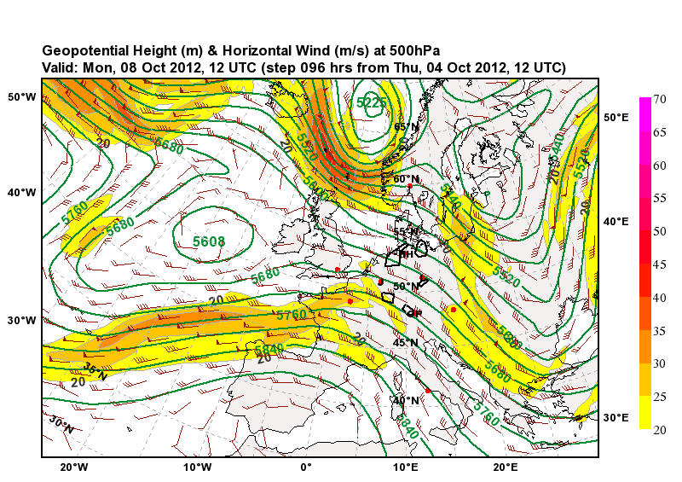

On Monday, the area around Oberpfaffenhofen is located in a north-westerly flow. An older WCB is associated with a tilted trough over the eastern North Atlantic. We expect some remnants of the outflow over Germany.

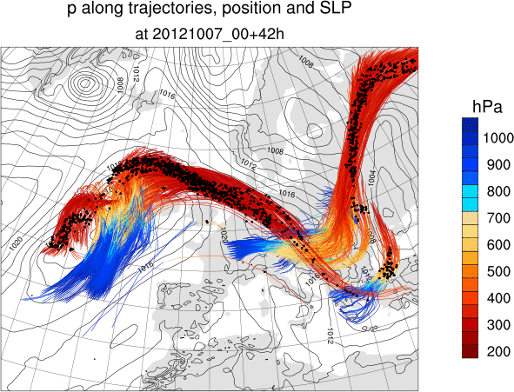
Outlook until Wednesday

High pressure builds over the central North Atlantic ocean and Rossby wave activity is shifted significantly further to the north than during the previous weeks. The deterministic IFS forecast predicts a trough east of the British Islands whose southern part extends as an elongated PV streamer to the south-west. The tilt of the streamer is very uncertain in the ECMWF ensemble. Some members (e.g. 02, 10, 13, 28, 46, 50) indicate interesting WCB activity associated with an extratropical cyclogenesis ahead of the trough. However, due to the uncertainty in the location of the trough/PV-streamer the ensemble shows a large variety in possible scenarios for the evolution in central Europe.

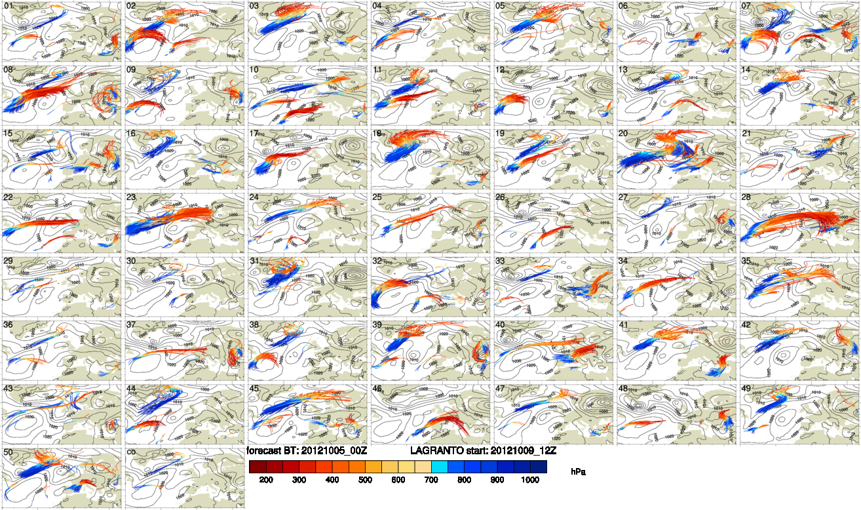
ECMWF ensemble forecast initialized at 20121015_00 and trajectories started at
20121009_12.

