T-NAWDEX Falcon 2012 Weather summary

Date (UTC): 20121007 15:00
Author: Christian Grams, Maxi Böttcher and Andreas Schäfler,

Synoptic Overview

Today an elongated cold front associated to a low pressure complex over Scandinavia affected large parts of Central Europe and approached southern Germany. A second large-scale low is situated over the Atlantic Ocean. Accompanied by the passage of the cold front, colder air is advected towards southern Germany on the rear side of the trough.

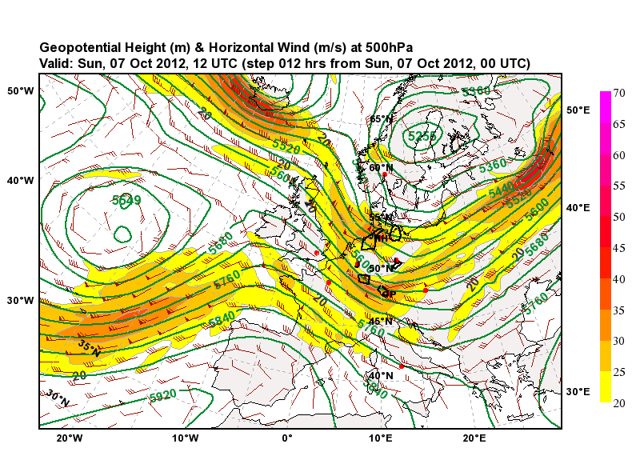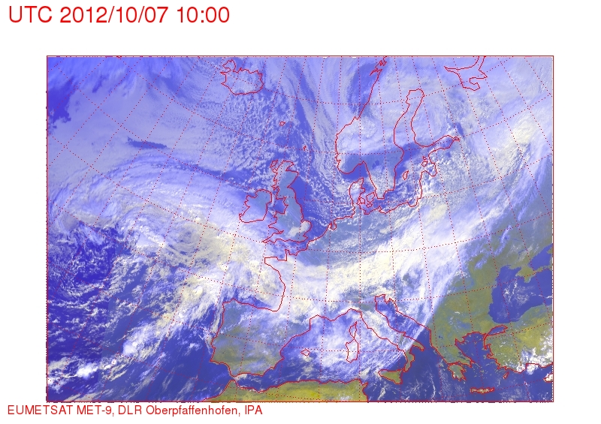

Forecast Day 1 (tomorrow)

Until Monday the Atlantic low remains stationary and southern Germany stays in a north-westerly flow. Embedded in the jet stream cirrus clouds are advected from the Atlantic low towards southern Germany during the day. The EPS WCB calculation indicates the clouds may have developed in connection with an older WCB in the Atlantic low pressure system.

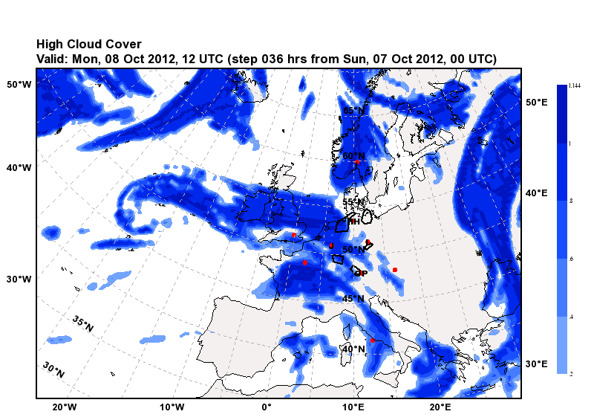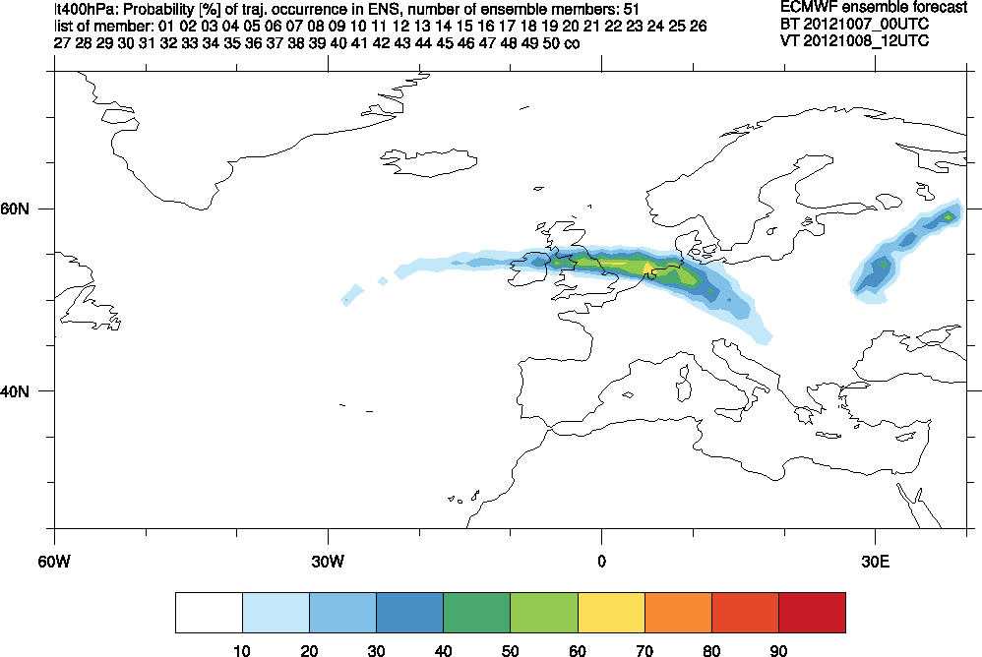

For the test flight which is scheduled for 13 LT (11 UTC) cirrus clouds are forecasted in the Allgäu TRA region. The cloud coverage of mid- and lower levels is low. The tropopause is located at about ~10 km altitude so that the Falcon will reach stratospheric air masses during the test flight.

Only outlook beyond Monday

Forecast Outlook

The IFS deterministic forecast and ECMWF ensemble (initial time 06/12Z and 07/00Z, discussing 07/00Z) indicate three potentially interesting WCB situations for next week.

1. Starting on Monday 08/12Z a secondary cyclogenesis occurs in the Channel (surface wave in pmsl). A WCB (smaller than usually expected) develops that ascends from Brittany, over northern France, southern Germany (north of the Alps) over Austria to the Black Sea. The inflow region gradually moves from the Channel(08/12Z-08/18Z), over northern and eastern France (08/12Z-09/06Z) to southern Germany (09/06Z-09/12Z). Ascent occurs on Tuesday (09) north of and over the Alps. An example is shown below. Only few ensemble member reflect this scenario.

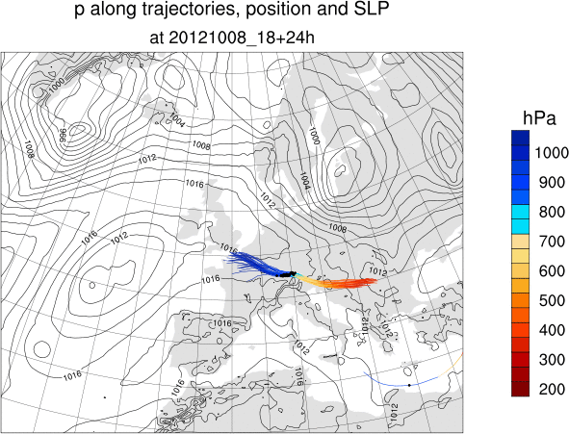

2. Starting on late Tuesday (09/18Z), several WCBs emerge in the eastern North Atlantic. (near 30W,50N ahead of a trough, to the SW of the British Isles and in the Gulf of Biscaya associated with the central low over the eastern Atlantic, and one near 15W,40N.). The latters outflow will pass over southern Germany on Thursday (11/00Z-11/18Z). Most interesting will be the WCB SW of the British Isles and in the Gulf of Biscaya.

The British Isles WCB emerges from Tue 09/18Z to Thu 11/00Z SW of the British Isles and over Ireland. The ascent occurs over the British Isles and outflow is expected over Scotland and further North. Strongly evident in the Ensemble (Probability of occurrence partly >60%).

The Gulf of Biscaya WCB emerges from Wed 10/06Z to Thu 11/06Z near the West Coast of France and over Brittany. WCB ascend occurs over northern France, the southern North Sea, southern England and outflow is expected over the northern British Isles and the north Sea. Evident in the Ensemble (Probability of occurrence partly >50%).

The following plot shows both WCBs with trajectories starting at Wed 10/18Z

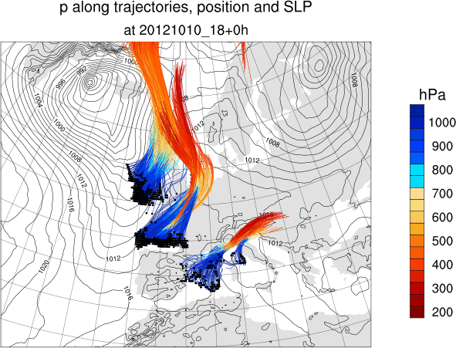

3. Beginning on Wednesday 11/12Z a WCB emerges from the western Mediterranean (around the Baleares Islands and later around Corse and Sardegna). Inflow occurs from Wed 10/12Z to Thursday. Ascent is over northern Italy and Slovenia (on Thursday/Friday), outflow over Hungary and Romania (on Friday 12 October).
The ensemble indicates a probability of WCB inflow of more than 30% (which is high) until Friday 12 October. The inflow region shifts from the Baleares northeastward more to the Med Coast of France (in the ensemble). The ascend would occur over northern Italy and the Alps on Saturday 13 October (ensemble).

The ensemble (07/00Z base time) shows several scenarios for the path of the trajectories e.g. over the Alps to the North (member e.g. 03, 42, 43) or following the IFS more eastward (01, 12, 49) or no WCB at all (23,25). Panel Plot for trajectories initialised at Fri 12/00Z.

