T-NAWDEX Falcon 2012 Weather summary

Date (UTC): 20121010 12:30
Author: Franziska Gierth, Philipp Reutter and Harald Sodemann

Synoptic Overview

The low over the Atlantic weakened and is now located over the Bay of Biscay. A deep low is coming from west with an elongated cold front over the Atlantic. The low over Scandinavia moved eastward out of interest. A high developed over Central Europe. The Alps are still under the influence of northerly flow and covered in clouds and rain. In southern Europe a cold front is approaching the Iberian Peninsula.

General forecast interest

We want to focus on Thursday/Friday and Sunday/Monday. On these days WCB activity is expected and flights are planned.

Forecast Thursday and Friday (11th and 12th of October)

During the last forecast the situation of the trough in the Med Sea was quite uncertain. The forecast now started to converge but don‘t show the results we hoped for. In the 08/12 forecast there was still high probability for WCB occurrence in the Med Sea. One day later the probabilities did not increase as expected and seen in the WCB over the British Isles but decreased. The same is valid for the Friday forecast. We are now waiting for the 10/12 forecast to decide if we fly or not.

fc 08/12 + 78h fc 08/12 + 96h
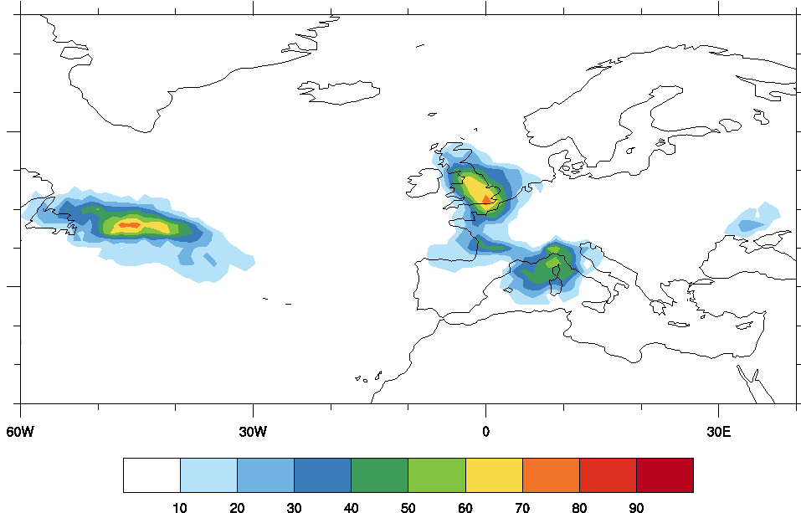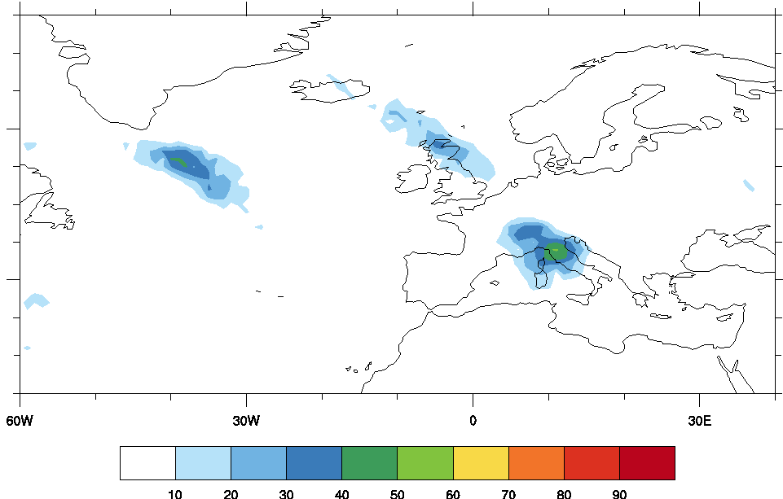

fc 09/12 + 54h fc 09/12 + 72h

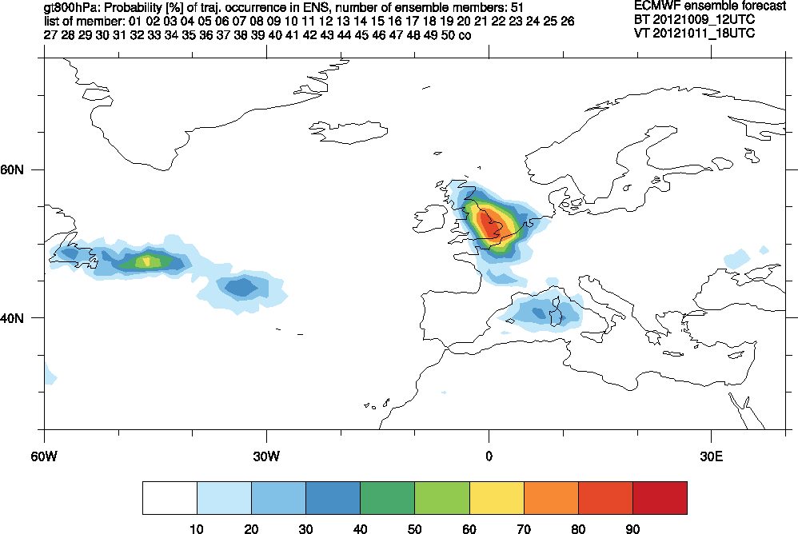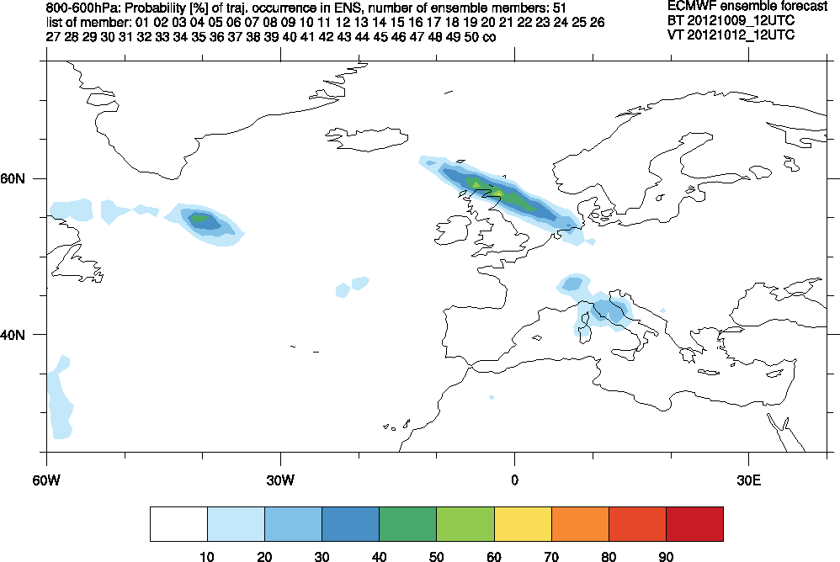

fc 10/00 + 42h fc 10/00 + 54h: 12_06

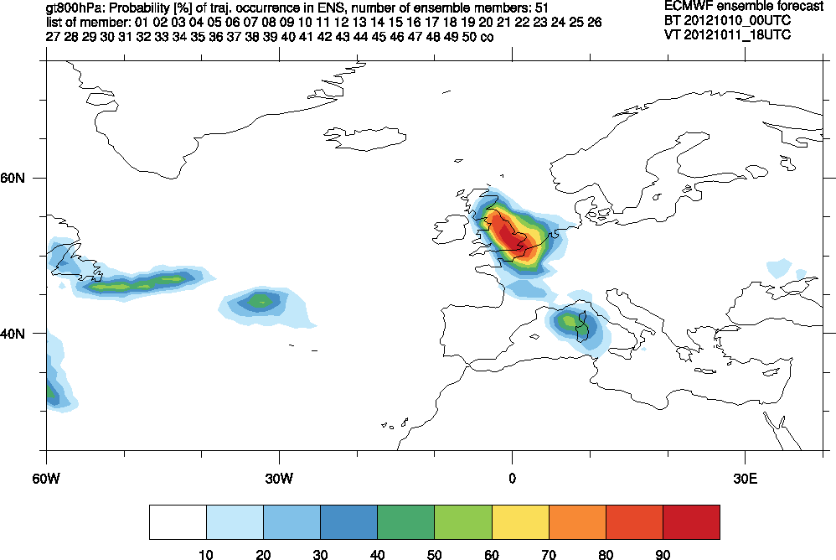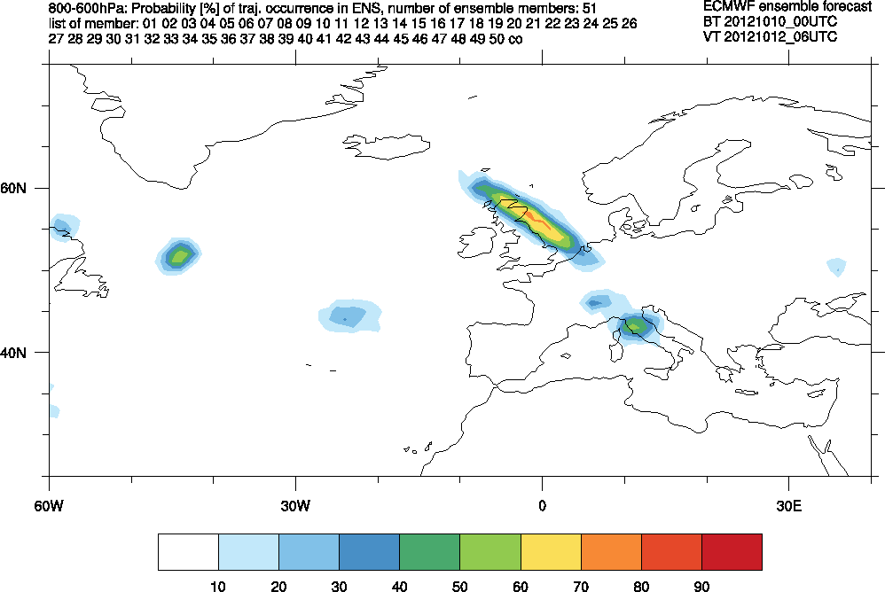

The probability of WCB occurrence. Left: > 800 hPa at 11/18. Right: 800<600 hPa at 12/12.

UPDATE:
The WCB probability from the 10/00 forecast in the Med Sea below 800hPa increased again and lies between 50% to 70% on 11/18, also on Friday 12/06 over Italy.
The trajectory calculations from the 10/00 forecast with ascent of at least 500 hPa look promising for WCB occurrence.

fc 09/12 + 54h fc 10/00 + 42h

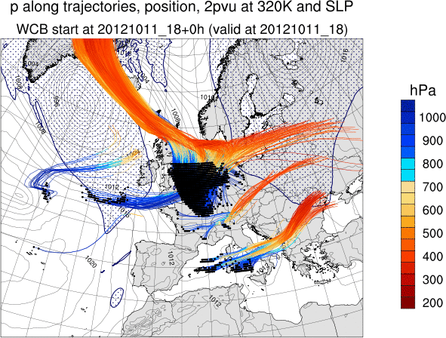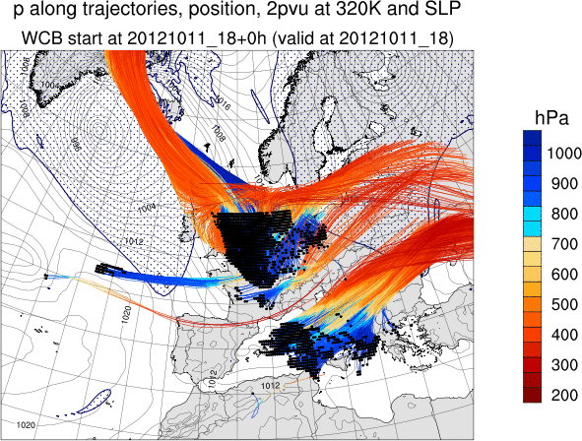

Outlook: Forecast Day 4-6 (Sunday to Tuesday )

Although more than 3 days in the future, we already observe the development of a low centered over the southern parts of the British Isles, based on the forecast started at 09/12.

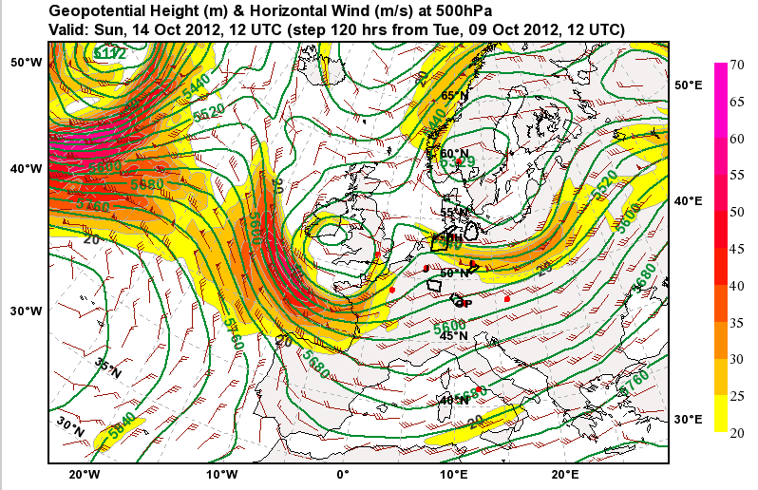

This low triggers the development of a warm conveyor belt with the inflow region from the Pyrenees to the Mediterranean Sea until the west coast of Sardinia. The probability of ascending air parcels on Sunday, 12 UTC in this region lies between 40 to 70 %.
The ascending part of the WCB starts over southern France and the western parts of the Alps, continuing to rise over most parts of Germany, finishing with the outflow region over southern Scandinavia.

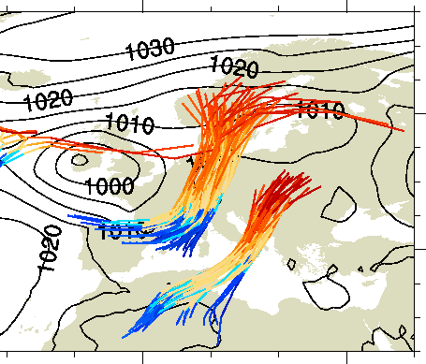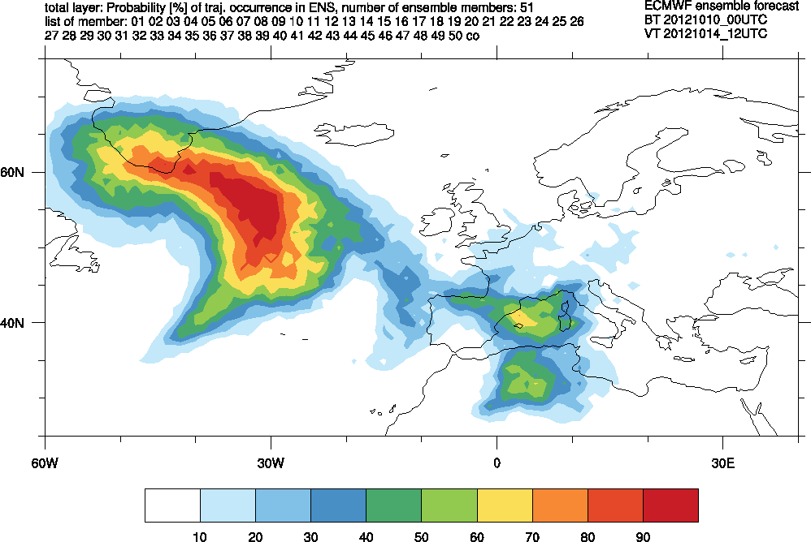
The ascend of the air parcels occurs along the precipitation pattern of the cold front, which ranges on Monday 06 UTC from the Mediterranean Sea, along the River Rhine up to the England.

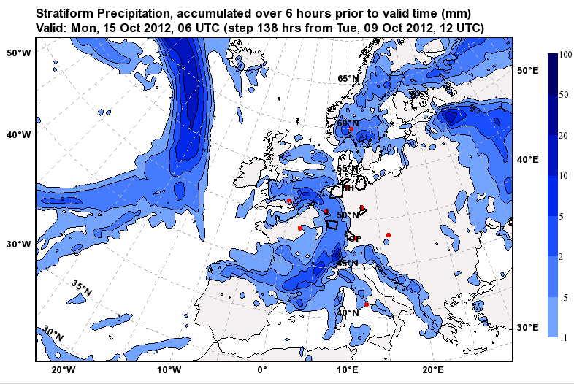

This constitutes a very favorable case for our tracer release experiment.

Model consistency for Monday 15th 12 UTC
The left side shows the forecast started at 09/12, the right side started at 10/12. The clear structure of the PV-Streamer, with the indication of the WCB (low PV), is reduced. Also the low-PV is shifted more to the east. However, the overall pattern seems to be stable.

