T-NAWDEX Falcon 2012 Weather summary

Date (UTC): 20121011 12:30
Author: Franziska Gierth, Philipp Reutter and Harald Sodemann

Synoptic Overview

A high dominates the weather over Central Europe and a deep low is approaching from the Atlantic. The elongated cold front passes the British Isles today and will reach Germany tomorrow.

General forecast interest

We want to focus on Thursday/Friday and Sunday/Monday. On these days WCB activity is expected and flights are planned. During the next week (Wednesday to Friday) new system will come into focus.

Forecast Thursday 11th (today)

Today the first flight is planned for the evening in the inflow region of the WCB.
The WCB probability from the ensembles of the 10/12 forecast > 800 hPa lies between 40% and 50% over the area of Corsica. The probability for the 11/00 decreased unfortunately again, but the trajectories still show good results.

fc 10/12 + 30h fc 11/00 + 18h
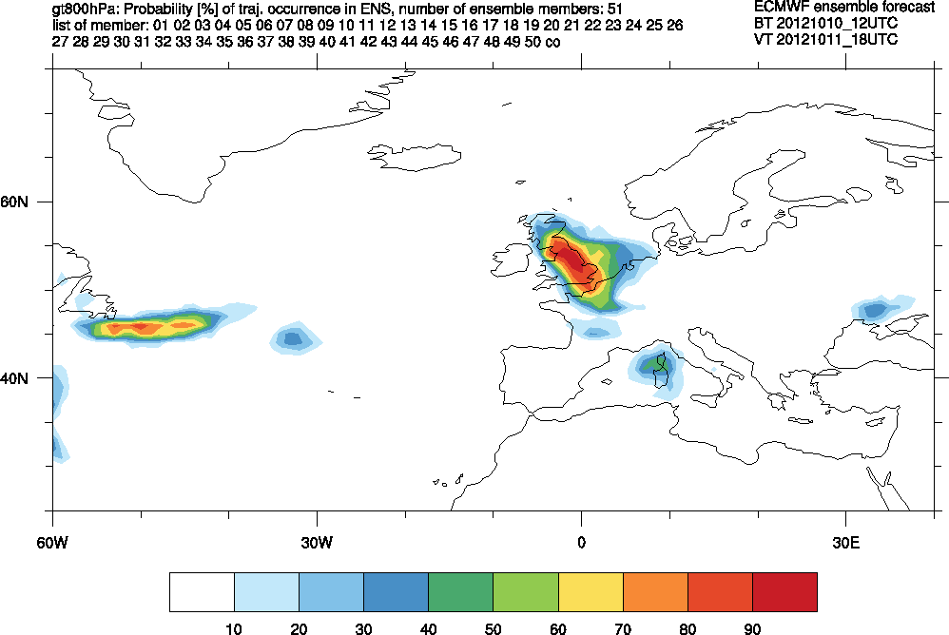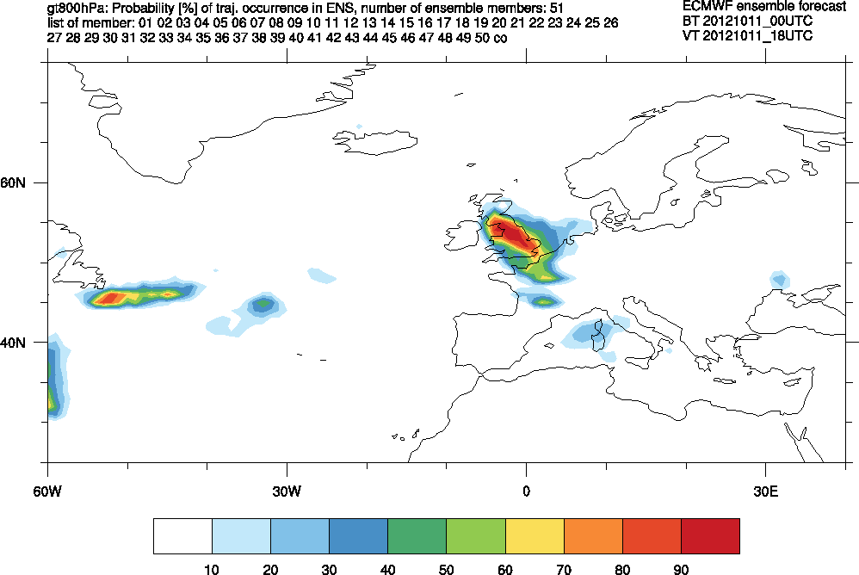

Probability of WCB occurrence > 800 hPa at 11/18.

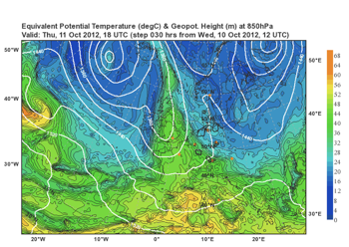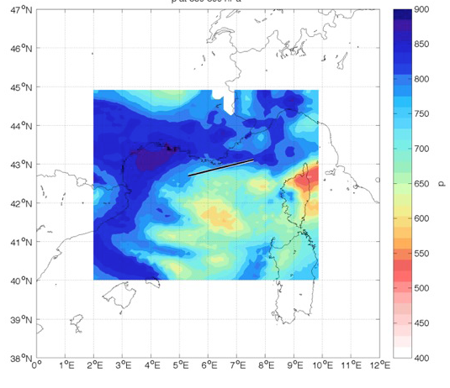

Left: Equivalent potential temperature @ 850 hPa on 11/18. Right: Region of ascending air on 11/18.

In the deterministic forecast (10/12) over the Med Sea a huge region of ascending air is located also west of Corsica in a warm sector. Our planned flight leg is located at the northern edge of this region.

Forecast Friday 12th (tomorrow)

The second flight will take place tomorrow over Italy in the ascending air and the outflow-region of the WCB.

fc 10/12 + 48h
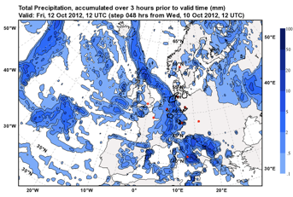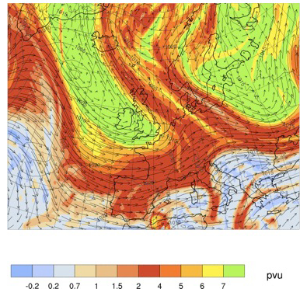

Left: Precipitation accumulated over 3h on 12/12. Right: PV@330K on 12/12.

Outlook: Forecast Day 3-5 (Sunday to Tuesday)

The forecast of the low pressure system over the southern parts of the British Isles for Sunday 14th 12UTC stabilizes, hence the development of the WCB over the western Mediterranean Sea looks very promising.

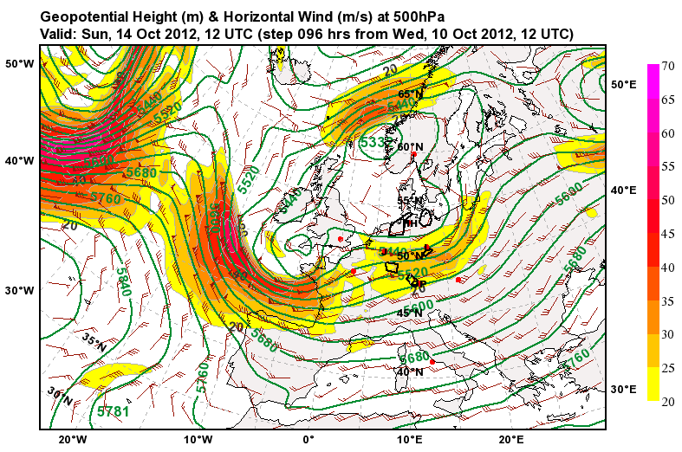

The inflow region of this WCB is distributed over most of the western Mediterranean Sea, with probabilities of up to 90% that ascending air parcels occur in a region west of Corsica.

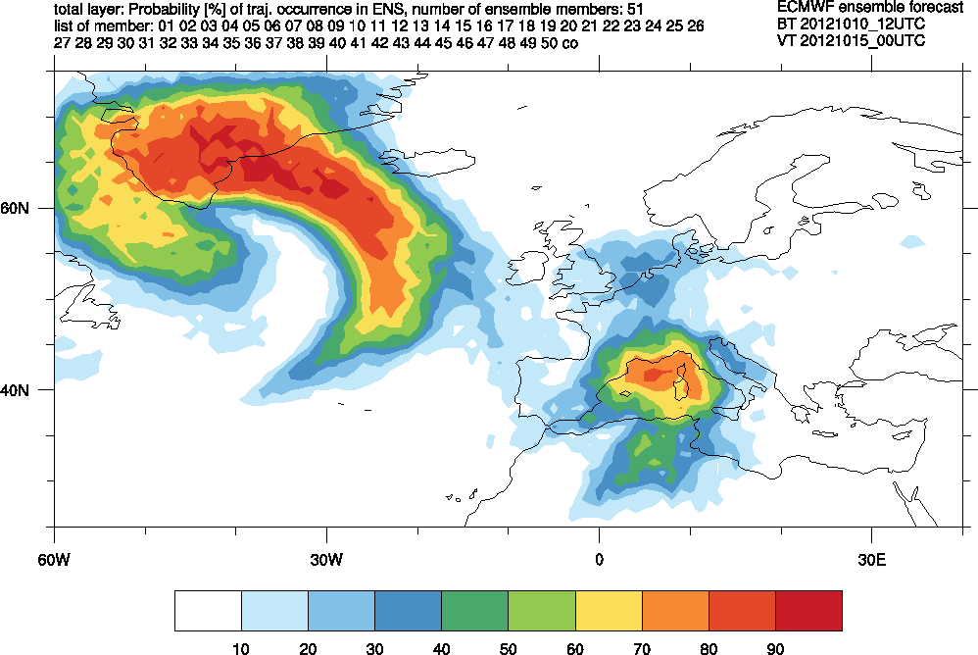

The trajectories of the control run from 10/12 for Monday 15th 00UTC confirm the large inflow area ranging from the Gulf of Valencia to Sicily. The air in this WCB is transported northwards heading to the Alps, where they start to rise.

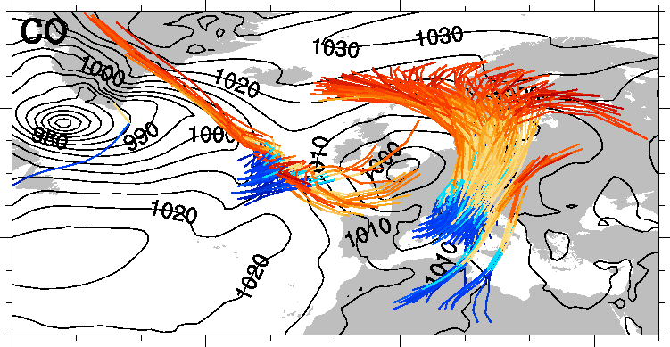

This leads to a strong precipitation event in the alpine region and Germany on Monday 15th 12UTC . On Tuesday this precipitation pattern moves further north to southern Scandinavia. This marks the outflow region of this WCB.

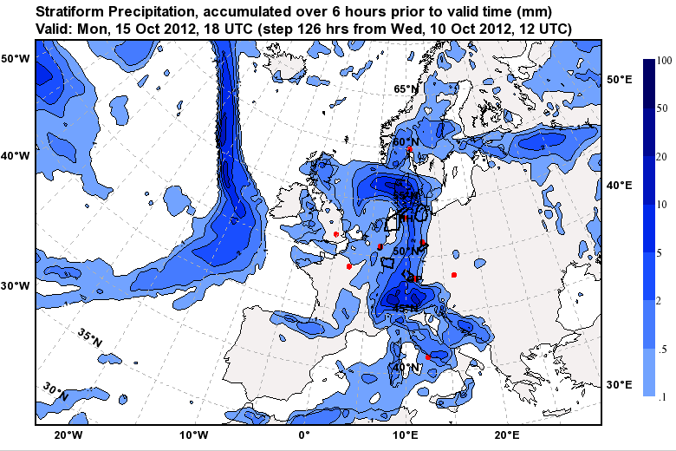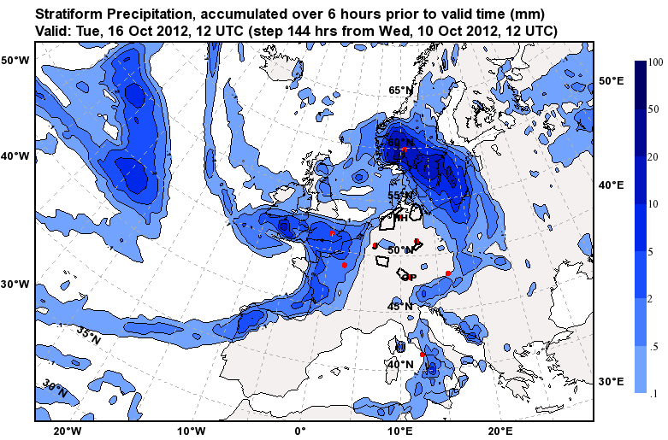

These promising conditions lead to the decision to conduct the tracer release experiment. The release of the tracer by the Partenavia is planned either for Sunday noon or Monday morning close to the Bay of Genoa or the south coast of France.

Update 1:15 pm: The WCB probability is up to 100 % in the Bay of Genoa.

Long term outlook:
For Thursday 18th the forecast shows an intense cyclone over the British Isles, where strong WCB activity can be expected. However, this forecast is for day 7 and hence the uncertainty is still high.

